**Science**

* Identify and name plants and animals which live within the savannah habitat; comparing this to the coastline habitat that was learnt about in the last half term.
* Explore how and why African animals and plants are suited to their surroundings.
* Investigate how animals depend on plants and each other for food, by creating simple food chains!
* Examine how different animals change and grow over time, looking at the life process from birth to death.

**Maths**

* Counting and comparing money – focusing on creating same amounts and finding differences.
* Improving our understanding of multiplication. We will be understanding the x2, x5 and x10 tables, using resources and pictures to show our understanding.
* Learning how to use arrays and implement them in our problem solving strategies.
* Learning some of the times tables off by heart.
* Learning about division and how it can mean sharing into equal groups.

**English**

* Become increasingly familiar with retelling stories, including a tale called ‘Lila and the Secret of Rain’ by David Conway through the use of speaking and listening activities (i.e. role play, story mapping, hot seating).
* Writing a diary entry from Lila about her journey to the top of the mountain to find the rain.
* Identify and use recurring language in stories set within Africa.
* Innovate a story about Egypt and explore the vocabulary involved. Heavily linked to history and the Egyption Gods, retelling and recounting facts about Egypt through our story telling.
* Use and understand grammatical terminology, such as noun, adjective, adverb, statement, question, exclamation, verb tense, apostrophe, comma.
* Improve handwriting skills, focusing on size, formation, and join.

**Geography/History**

* Use maps and atlases to locate the world’s continents and oceans; exploring their positon in relation to the equator and the two poles.
* Develop an understanding of the African continent and its countries. Focusing on Kenya and Egypt.
* Identify the human (i.e. city, town, village, farm, house) and physical features of an area (i.e. forest, hill, mountain, river, vegetation, climate).
* Explore life in an African village.
* Compare the similarities and differences of life in Ancient Egypt and modern Egypt.

**Music**

* Learn about African drums called ‘Djembe ‘drums with a specialist drumming teacher!
* Explore how different sounds can be created with different parts of an instrument.
* Lean about low and high pitch.
* Explore and develop skills in rhythm.
* Explore voices expressively and creatively by singing African songs as well as speaking chants and rhymes.
* Play tuned and un-tuned instruments musically.

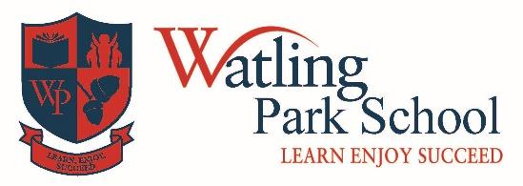

**“Africa”**

**Year 2**

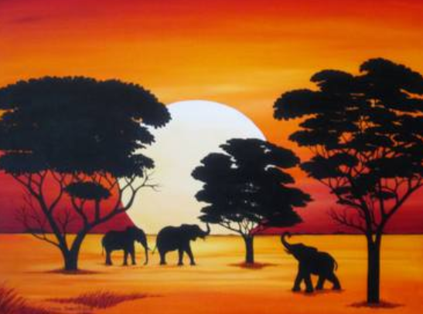

**PSHE**

* Celebrating black history through a week of literacy dedicated to an individual.
* Identify dreams/goals that are important.
* Explore how to overcome challenges and obstacles.
* Celebrating our differences as people within our communities.

**Art and Design**

* Explore and create traditional African dishes! Cooking with the teacher to explore the culture through food.
* Learning about Edward-Saidi Tingatinga and exploring a wide range of multimedia art techniques.

**Computing**

* Exploring what algorithms are; how they are implemented as programs on digital devices and what programs execute by following precise and unambiguous instructions.
* Create and debug simple programs, through the use of beebots.
* Use logical reasoning to predict the behaviour of simple programs.

**PE**

* Develop balance, agility and co-ordination.
* Perform dances using simple movements.
* Move in time to music.

**Religion**

* Exploring why Christians believe in God, and how they believe that God gave Jesus to the world.