Reading
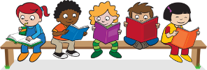
Read every day for at least 15 minutes, recording your progress and completing the comments section within your reading diary. Discuss each book with an adult, answering some of the questions provided on the reading guidance.
Reading diaries must be signed by your parent/carer before the book may be changed.
Spelling
Practise the spellings that are kept in the cover of your home learning book. Do this at least 2 to 3 times per week using one or more of the strategies listed on the ‘Strategies List’. Guidance can be found on the home learning section of the website.
Number Facts
We have invested in ‘Mathletics’, an online maths platform. Log on at least 3 times each week to practise Year 2 maths skills and have fun at the same time! You can practise multiplication and division facts for the 2, 5 & 10 times tables.

Topic
Each week choose and complete a different activitiy from those provided within the table. These activties are based upon the current topic, ‘Muck, Mess and Mixtures’, and will support and extend your learning. Try completing at least one ‘Three Star Challenge’ each half term.
Other
If necessary, occasional additional tasks may be provided to further support your progress.
See the website for parent/carer guidance on how best to support at home along with additional activity suggestions.
Please read the home learning for this term and ask your class teacher if you have any questions or queries.

Topic:
Muck, Mess and Mixtures
I enjoy reading, writing and speaking. | Tell someone at home about our story, ‘The Magic Porridge Pot’. What was their favourite part?  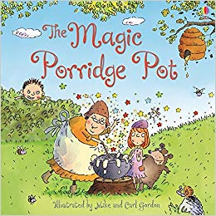 | Go to the library and take out a book about different materials. Write 3 key things that you learn. | Prepare a presentation about how to be safe with different liquids. Be prepared to talk to the class for 3-5 minutes about it. Please let your teacher know if you have chosen this so that we can make time in the day.
I enjoy working with numbers as well as working scientifically. | Make a list of different ingredients in a mixture. Can you sort them into different categories? | Ask an adult to help you measure and mix different ingredients for George’s new Marvelous Medicine. (Do not eat) | Research and record different materials that make bubbles. What do you notice?
I enjoy painting, drawing and visualising. | Draw or paint all the ingredients to make porridge. Make sure you label your diagram.  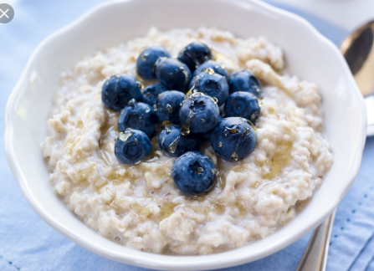 | Use paint or food colouring to try and create your own marble art. You can use the internet to help you. | Make a model of a healthy meal. Do not use real food, see if you can find materials to represent those foods. You can paint recycled materials or draw pictures.
I enjoy being active and hands-on. | Act out a scene from ‘The Magic Porridge Pot’ to a member of your family. Use props and expression in your voice.  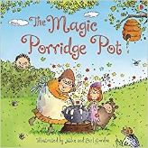 | Make a mixture of garden items. See how the leaves are changing colour as we enter winter. Draw a picture of what you did. | Follow a recipe to make or bake something with an adult. Take pictures and write what happened in each step.  List all the ingredients in your mixture.

Parents/carers: For each activity, once completed, write the date and sign/initial below the activity description. Feel free to write a comment.

