**Maths**

* Counting and comparing money – focusing on creating same amounts and finding differences.
* Improving our understanding of multiplication. We will be understanding the x2, x5 and x10 tables, using resources and pictures to show our understanding.
* Learning how to use arrays and implement them in our problem solving strategies.
* Learning some of the times tables off by heart.
* Learning about division and how it can mean sharing into equal groups.

**Science**

* Explore different habitats found within Africa (i.e. desert, savannah, jungle).
* Identify and name a variety of plants and animals.
* Name and describe body parts for different animals (i.e. beak, hooves, trunk).
* Investigate why living things are suited to each habitat, or micro-habitat.
* Describe how animals obtain their food from plants or other animals; exploring simple food chains.
* Understand that animals have a life cycle and learn the names for some offspring (i.e. calf, foal, chick).

**English**

* Become increasingly familiar with retelling stories, including a tale called ‘Lila and the Secret of Rain’ by David Conway through the use of speaking and listening activities (i.e. role play, story mapping, hot seating).
* Listen to, and discuss a range of stories and non-fiction texts; exploring how the sequence of events as well as items of information are related.
* Identify and use recurring language in stories set within Africa.
* Compose non-chronological reports about African animals; organising information using subheadings.
* Use and understand grammatical terminology, such as noun, adjective, adverb, statement, question, exclamation, verb tense, apostrophe, comma.
* Improve handwriting skills, focusing on size, formation, and join.

**Geography**

* Use maps and atlases to locate the world’s continents and oceans; exploring their positon in relation to the equator and the two poles.
* Develop an understanding of the African continent and its countries.
* Identify the human (i.e. city, town, village, farm, house) and physical features of an area (i.e. forest, hill, mountain, river, vegetation, climate).
* Explore life in an African village.
* Compare the similarities and differences of life in a Kenyan village to life in Burnt Oak.

**Music**

* Learn about African drums called ‘Djembe ‘drums with a specialist drumming teacher!
* Explore how different sounds can be created with different parts of an instrument.
* Lean about low and high pitch.
* Explore and develop skills in rhythm.
* Explore voices expressively and creatively by singing African songs as well as speaking chants and rhymes.
* Play tuned and un-tuned instruments musically.



**“Africa”**

**Year 2**

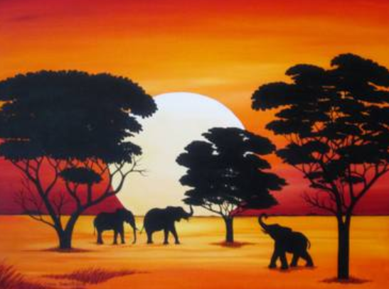

**Art and Design**

* Explore and use a variety of techniques, including colour, pattern, texture and shape.
* Investigate a range of materials creatively to design and make collages.
* Produce a mixed media African scene.

**PSHE**

* Identify dreams/goals that are important.
* Explore how to overcome challenges and obstacles.

**Computing**

* Develop an understanding of how to use technology safely and respectfully, by keeping personal information private, as well as identifying where to go for help and support when they have concerns.
* Conduct research about Africa, using the Internet purposefully.
* Create and debug simple programs.

**PE**

* Develop balance, agility and co-ordination.
* Perform dances using simple movements.
* Move in time to music.

**Religion**

* Explore how celebrating Passover helps Jews show God they value their special relationship with Him.