Reading
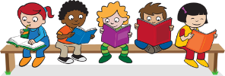
Read every day for at least 15 minutes, recording your progress and completing the comments section within your reading diary. Discuss each book with an adult, answering some of the questions provided on the reading guidance.
Reading diaries must be signed by your parent/carer before the book may be changed.
Number Facts
- Practise counting to 20 at least 5 times every day.
- See if your child can use ‘more’ and ‘fewer’ to compare things around the house (eg. two sets of objects like plates, cutlery or clothes).
- Practise counting on from any given number.
- Practise estimating how many objects in a set.
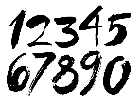
- Can they say the number that is one more than a number you give them? Talk about adding and subtracting (taking away) and begin to use the vocabulary linked to this.
- Practise number bonds to 10 (how many different ways can you make 10).
- https://www.oxfordowl.co.uk/
- https://uk.ixl.com/
- http://www.crickweb.co.uk/Early-Years.html
- https://www.bbc.co.uk/cbeebies/topics/numeracy
Topic
Each week choose and complete a different activitiy from those provided within the table. These activties are based upon the current topic, ‘Are we there yet’, and will support and extend your learning. Try completing at least one  ‘Three Star Challenge’ each half term. |  | 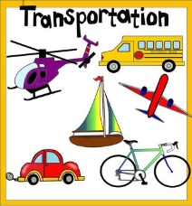
Tricky words
Practise the set tricky words given below. When your child can confidently recognise them , they will be given the next set of words. Have a go at using tricky words in sentences.

they | what | have | she | he
all | like | are | your | there

Reception have changed the format of home learning this term to be consistent and in line with the rest of the school’s home learning which we have had positive feedback from. Please read the home learning for this term and ask your class teacher if you have any questions or queries.

Table of activities
Topic
I enjoy reading, writing and speaking. | See how many modes of transport you can name! You might need to look at pictures of them on the internet or in books first. Record your list in your book. | Find a book about transport. It could be a story or an information book. Talk about the book with your family. Write about your favourite part or something you learnt. | Make an information poster about your favourite transport. Include some interesting facts.
I enjoy working with numbers as well as working scientifically. | Observe a plant or flower growing. Talk to your grown up or family about what a plant need to grow. Draw the plant or flower you observed. | Plant a seed at home.  Make observations about what happens during the week.  Draw and label the seed starting to grow. | Observe the changes to the plant/ flower.  Use a ruler to measure how tall your plant/flower has grown.  You could keep a diary and draw pictures to show what happened.
I enjoy painting, drawing and visualising. | Pick a vehicle and design and make it. You could draw, paint or use junk modelling. | 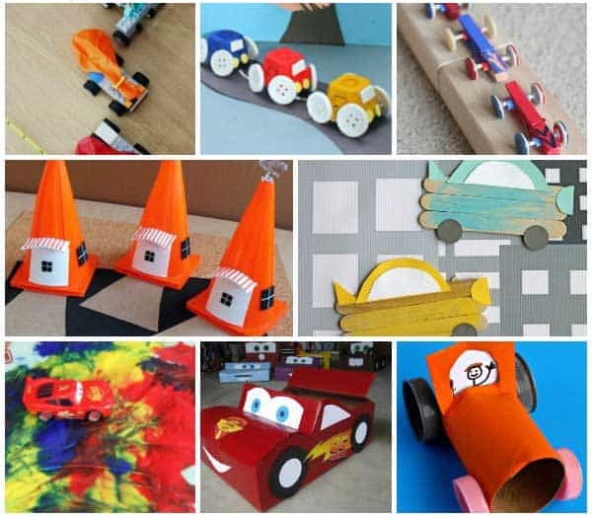  Pick your favourite vehicle and create a 3D version of it using boxes and cardboard. | Invent your own vehicle.  It could be a flying car or a floating bicycle. You could show this in your own way. E.g drawing/ creating it on the computer/ model…
I enjoy being active and hands-on. | Think about the different types of transport you could use to come to school. What do you use at the moment? Do you use any? Try to use a different type of transport to come to school. Draw or write about your experience. | Explore different vehicles e.g the bus, train, scooters, bicycles, cars. Discuss which ones have wheels, which ones did not.  Count how many have  2 wheels, 3 wheels, 4 or more wheels | Having explored different vehicles, which one made your heart beat the fastest?  Write down why you think that.

Parents/carers: For each activity, once completed, write the date and sign/initial below the activity description. Feel free to write a comment.

