Reading
Read every day for at least 15 minutes, recording your progress and completing the comments section within your reading diary. Discuss each book with an adult, answering some of the questions provided at the front of the reading diaries.
Books should be changed at least once per week depending on the book length. Reading diaries must be signed by your parent/carer before beginning a new book.
Spelling
Practise the provided spellings (from the Year 3 & 4 list) at least two to three times per week, using one or more of the strategies listed at the front of the homework books.
Number Facts
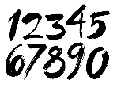 | Develop your maths knowledge further by completing the activities set on ‘Mathletics’, which are linked to our current chapter.  By the end of Year 3, you are expected to know the 2, 3, 4, 5, 8 and 10 times tables, including the related division facts fluently.
Topic
Each week choose and complete a different activitiy from those provided within the table. The majority of activties are based upon the current topic ‘Roaming Romans’, but all will support and extend your current learning. Try completing at least one ‘Three Star Challenge’ each half term. |  | 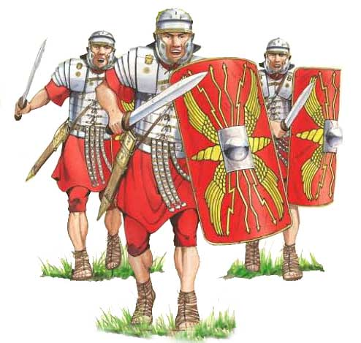
Other
If deemed necessary, additional tasks may be provided occasionally to further support your progress.
See the website for parent/carer guidance on how best to support at home along with additional activity suggestions.

Topic
I enjoy speaking and reading. | Look at a picture of a volcano. Tell your grown-up 5 interesting adjectives to describe the volcano. | Read a non-fiction book about natural disasters. Tell your grown-up what you have learnt. | With help from an adult, read a newspaper article about a natural disaster which has happened (e.g. Australian bush fires.) Tell your grown-up what you have learnt.
I enjoy writing. | Look at a picture of a city after an earthquake. Write 10 descriptive phrases using interesting adjectives to describe what you see. | Imagine you are a hurricane. Write a poem from the hurricane’s point of view. Include feelings thoughts and motives. | Write a newspaper report about a famous hurricane. Challenge: use direct speech from witnesses.
I enjoy working with numbers. | Make a rock/pebble tower, how many can you stack before it collapses? | Find 5 rocks, use a ruler to measure their height and width in centimetres. Record the information in a table. | Research 10 volcanos. Order them according to height (in metres).
I enjoy working scientifically. | Create a glossary of 10 technical words used when exploring rocks, fossils and soil. | Use a thermometer to record the temperature of each day for a week. Present the data as a bar graph. | Research 10 earthquakes. Order them according to how powerful they were (according to the magnitude scale).
I enjoy painting, drawing and being hands-on. | Paint or draw a picture of a volcano. | Make some slime which looks like lava. | Draw a cartoon strip showing how fossil are formed.  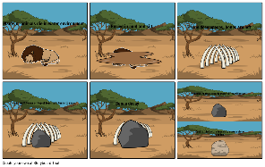
I enjoy being active. | Go on a fossil hunt. At the end, whatever the result, use a stick to draw a fossil in the mud. | Recreate the effects of a tsunami. Build a small hut using twigs, rocks and leaves etc. Throw a bucket of water over the top. What happened to the hut? Why do you think that happened? What could you do to the hut to stop this happening a second time? Try it. | Create a dance routine to represent the effects of different natural disasters.  E.g. spinning around to represent a hurricane. Get creative!

Parents/carers: For each activity, once completed, write the date and sign/initial below the activity description. Feel free to write a comment.
Remember learning can take many forms and does not need to take place at home. Go to an art gallery, explore the books at your local library, attend local/community events and/or visit historic sites around Londinium (i.e. St. Albans, where you will find many Roman features).

