Reading
Read every day for at least 15 minutes, recording your progress and completing the comments section within your reading diary. Discuss each book with an adult, answering some of the questions provided at the front of the reading diaries.
Books should be changed at least once per week depending on the book length. Reading diaries must be signed by your parent/carer before beginning a new book.
Spelling
Practise the provided spellings (from the Year 3 & 4 list) at least two to three times per week, using one or more of the strategies listed at the front of the homework books.
Number Facts
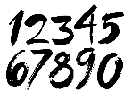 | Develop your maths knowledge further by completing the activities set on ‘Mathletics’, which are linked to our current chapter.  By the end of Year 3, you are expected to know the 2, 3, 4, 5, 8 and 10 times tables, including the related division facts fluently.
Topic
Each week choose and complete a different activitiy from those provided within the table. The majority of activties are based upon the current topic ‘Roaming Romans’, but all will support and extend your current learning. Try completing at least one ‘Three Star Challenge’ each half term. |  | 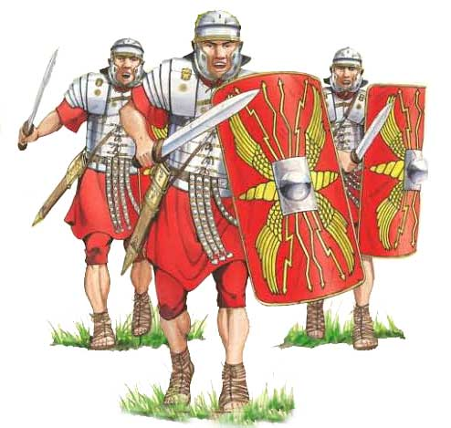
Other
If deemed necessary, additional tasks may be provided occasionally to further support your progress.
See the website for parent/carer guidance on how best to support at home along with additional activity suggestions.

Topic
I enjoy speaking and reading. | Tell your parents 5 things you now know about the Romans. This could include facts about the Roman army, myths or the Roman Empire. | Choose a Roman myth and retell it in your own words to members of your family. | Create and deliver a presentation about facts about the Romans that you have researched on the Internet and in books.
I enjoy writing. | Imagine you are a Roman solder. Write a list of all the clothes and/or objects you would need to be a strong soldier. | Create a word search for someone to solve containing at least 5 topic words. | Imagine you are living during Ancient Rome. Write a letter to your future self describing what life is like, where you live and what is going on in the news.
I enjoy working with numbers. | Play mathematical games with your family. For example, Snakes and Ladders, Ludo, Connect 4, Dominoes, Uno, Battleships and Monopoly etc. | Represent these 3-digit numbers by drawing pictures.  254, 627, 341, 729  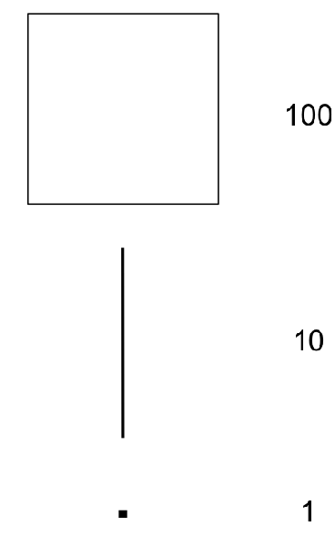  Below are some examples to help. | Write the numbers 1-20 in Roman numerals. Then create a poster showing some simple addition problems using these numerals.
I enjoy working scientifically. | Make a Venn diagram for your toys, sorting them into ‘push’, ‘pull’ or ‘neither’, depending on how they work. | Make a list of magnetic items in your home. If you have a magnet at home, test them out. What do you notice about the material they are made of? | Invent a toy which needs push and pull forces for it to work. Draw and label your creation, and write an explanation of how the forces are used.
I enjoy painting, drawing and being hands-on. | Draw or paint a picture of a Roman soldier and label it.  (If you are painting, please make your painting on a separate piece of paper, then stick it into your home learning book). | Create a battle scene between the Celts and the Romans – be creative, use any materials!  e.g. Lego, plasticine, tissue paper, foil, paint | Research a famous Italian artist (e.g. Michelangelo, Donatello, Leonardo, Raphael). Create a piece of artwork in their style. Discuss what you have learnt with your family.
I enjoy being active. | Practise your batting skills. How many ‘keepy-uppys’ can you do before it hits the ground? Can you beat your personal best? | Go to a garden or outdoor space, practise netball pivots and throws.  Start with throwing chest passes and bounce passes. Can you throw a shoulder pass? (One hand). | In order to join the Roman army, solders must be strong. Create a ‘Get Strong’ fitness plan for a new soldier to follow. Draw/write it, and then teach it to your family to prove it works! Photos are welcome!

Parents/carers: For each activity, once completed, write the date and sign/initial below the activity description. Feel free to write a comment.
Remember learning can take many forms and does not need to take place at home. Go to an art gallery, explore the books at your local library, attend local/community events and/or visit historic sites around Londinium (i.e. St. Albans, where you will find many Roman features).

