Reading
Read every day for at least 15 minutes, recording your progress and completing the comments section within your reading diary. Discuss each book with an adult, answering some of the ‘Questions for Reading’.
Books should be changed at least once per week depending on the book length. Reading diaries must be signed by your parent/carer before beginning a new book.
Spelling
Complete the ‘Spelling Word Search’ and practise the corresponding words at least 2 to 3 times per week using one or more of the strategies listed on the ‘Strategies List’.
Number Facts
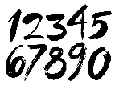 | Develop your maths knowledge further by completing the activities set on ‘Mathletics’.  Practise your multiplication tables every day. This can be done in a variety of ways, including playing card and dice games, chanting and/or the free online game ‘Hit the Button’.
Topic
Each week choose and complete a different activitiy from those provided within the table. The majority of activties are based upon the current topic ‘Crime Doesn’t Pay!’, but all will support and extend your current learning. Try completing at least one ‘Three Star Challenge’ each half term.
Other
If deemed necessary, additional tasks may be provided occasionally to further support your progress.
See the website for parent/carer guidance on how best to support at home along with additional activity suggestions.

Topic
I enjoy speaking and reading. | Listen to the news and/or read a newspaper. Make a list of the crimes reported and how the criminals were punished. | Find a poem about crime and/or Punishment, and perform it to your family. | Research some of the strange laws from around the world. For example: there is a law in New Zealand that states you cannot fly with a rooster in a hot air balloon. Discuss what you have learnt with your family.
I enjoy writing. | Create a word search for a peer to solve containing at least ten topic words. | Imagine you are in charge of the country. Make a list of the top ten laws you would enforce.  What would the punishment be for breaking each law? | Imagine that you are living during the Victorian period. You want the Queen to abolish public executions, such as hanging, and increase the size of the police  force. Write a persuasive letter to Queen Victoria explaining your reasons.
I enjoy working with numbers. | 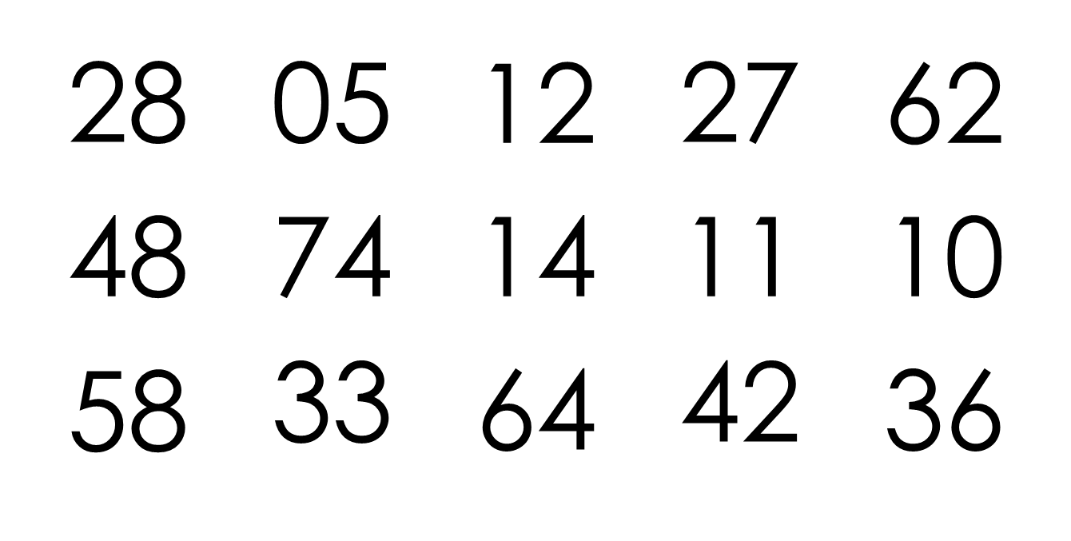  A thief has dropped the numbers that helped him/her open the safe. The code is made up of products that appear in the 4 times table. Find the products, and write them in ascending order. What was the code? | Cook/bake anything in the shape of a key to escape from your prison cell. You can be as creative as you wish, just don’t eat it before you have escaped! Record the quantity of each ingredient used (i.e. 500g of flour). | Sherlock Holmes has narrow-ed his suspects down to two. He knows that the culprit did not retrace his steps as there are footprints leading to and from the crime scene. Who is guilty? Why?
I enjoy working scientifically. | Finger print your family. Gently colour over the index finger with a pen and then press onto the paper. Write the name of the person next to each finger print. What do you notice? | Record all the different ways that you use electricity for a day (e.g. switched on lights, played on a tablet etc.). Now decide if each use was ‘essential’ or ‘non-essential’.  How I used electricity? Essential or non-essential?  How could you reduce your electricity use? | Design an electrical appliance that performs a really fun job. Draw it, label it and explain why everyone should want one.
I enjoy painting, drawing and being hands-on. | Create a picture using only your finger prints. | Research a famous graffiti artist (i.e. Banksy). Create a piece of artwork in their style. Discuss what you have learnt with your family. | Design a wanted poster for a famous real or fictional criminal (e.g. Jack the Ripper, Voldemort, Moriarty…). Remember to include their crime and a reward.
I enjoy being active. | Practise your ball-handling skills. Can you move the ball around your head using both hands? Try throwing the ball straight into the air and lapping before catching it again with both hands. How many times can you clap in between throwing and catching?  Use a rugby ball, if you have one, although any large ball will do! | Practise the sidestepping movement, which is often use to try and get past defenders. Place two cones (or similar) approximately three metres apart and sidestep between them as quickly as you can. Remember to keep a low body position and to be quick and light on your feet. How many times can you move between comes in one minute? | In order to catch criminals, police officers sometimes have to chase them. Create a ‘Get Fit’ regime for a police officer to follow. Draw/write it, and then teach it to your family to prove it works!

Parents/carers: For each activity, once completed, write the date and sign/initial below the activity description. Feel free to write a comment.
Remember learning can take many forms and does not need to take place at home. Go to an art gallery, explore the books at your local library, attend local/community events and/or visit historic sites around London (i.e. The London Dungeons).

