Welcome
to
Year 2
2019-20
Learn – Enjoy – Succeed

Miss Landsberg
Miss Neale

Head of Year: Mrs Whitcombe

Year 2 will be an exciting and challenging year for your child. Building on the skills they have gained within Year 1, the emphasis will continue to be on cultivating independence and confidence along with developing the characteristics of effective learning. Within all subjects, the children will develop as confident, inquisitive learners in the knowledge that their work and contributions are highly valued.
The School Day
The school gates open at 8:35am each morning. The bell rings at 8:45am and lessons begin promptly. Parents are asked to leave their child in the playground as soon as the bell rings, allowing them to enter school on their own. This encourages independence and a quick and smooth transition into class. The gates will be closed at 8:50am.

At the end of the day, the school gates reopen at 3:25pm and the school day ends at 3:30pm. If you are unable to collect your child, please inform the office and/or class teacher, identifying who will be collecting. A password will be required to release your child to the nominated parent/adult which should be logged with the office.

Playtime
In Year 2, there is one playtime of 15 minutes at 10:45am in addition to a one-hour lunch break from noon. Outdoor equipment will be provided for the children to use. They may also have an afternoon playtime of 15 minutes, at the teacher’s discretion.

Lunch
In 2014, the Universal Infant Free School Meals (UIFSM) policy was introduced, stipulating that all children within Reception, Year 1 and Year 2 should be entitled to a healthy free school lunch. As a school, we expect all children within these year groups to take up the offer, unless there is a specific dietary requirement which prevents this.

The school kitchen provides us with a well-balanced nutritional menu; typically, this will be a hot meat or vegetarian meal with salad/vegetables, yoghurt and fruit as a dessert. We make every effort to meet the dietary requirements of children within school, special requirements must be shared with the office staff.

Children eating packed lunches take their lunch at the same time as the other children. Please ensure that they have a healthy lunch including a piece of fruit each day. Their food must not include any nuts, fizzy drinks or chocolate!

Note: Should your child wish to change from or to school dinners, you will need to provide the office with at least three weeks’ notice.

Extended Day Provisions
We provide additional services before and after the normal school day to support our busy families as well as help the children achieve their full potential. These services include a breakfast club, and a wide range of after-school activities. For further information about current availability, please contact the school office (office@watlingparkschool.org.uk) or the Extended Day Provision Lead, Miss Lulu (clubs@watlingparkschhol.org.uk).

Communication
Although the school has an open door policy, it is important that teachers are not distracted whilst supervising the children which includes when collecting and dismissing the children at the start and end of the day.

Minor concerns or messages may be shared quickly during this time, however, for longer or more confidential conversations, an appointment should be made, either directly with the member of staff or through the office.

Note: Parents should always contact the class teacher in the first instance before progressing to a more senior member of staff.

Whilst we make every effort to be proactive in informing parents about important events which have taken place during the day, this is not always immediately possible.
The School Curriculum
National Curriculum
Children will follow the age related expectations for Year 2 outlined within the National Curriculum [Appendix A].

Core Subjects | Foundation Subjects
English – Reading and Writing | Art and Design
Mathematics | Design and Technology
Science | Geography
 | History
 | Computing
 | Music
 | Physical Education (PE)

Schools are also required to teach RE (Religious Education) as well as PSHCE (Personal, Social, Health and citizenship Education). Children might often refer to ‘Jigsaw’ instead of PSHCE as we follow a whole school approach where each lesson is referred to as a piece of a bigger puzzle.

Cross Curricular Topics
Across the whole school, we take a cross-curricular approach to learning. Through a main topic, such as ‘Land Ahoy!’, learning is put into context by the integration and coherent sequencing of knowledge and skills from all subject areas. This makes learning broad and balanced whilst developing enjoyment and motivation, higher order thinking and questioning skills, curiosity and independence.

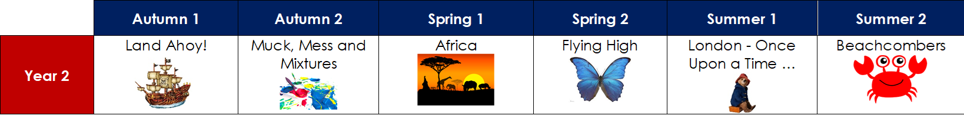

See the ‘Curriculum Overview’ and ‘Topic Webs’ (which are published at the beginning of each term) for further information about each topic taught.

English – Reading
During the school week, there will be multiple opportunities for your child to explore a range of different texts either through a class book linked to the topic, as part of their Read Write Inc. Phonics sessions, within guided reading sessions and/or individually during quiet reading.

English – Writing
Children are given a variety of opportunities to write in many different genres (i.e. narrative, recount, report, instructions, etc.) across the curriculum. They are encouraged to develop their work by writing consistently in full sentences, using more sophisticated grammar and descriptive language in order to engage the reader. The importance of accurate punctuation in all forms of writing is not only encouraged but expected.

Children continue to learn and apply spellings taught during Phonics in all writing across the curriculum, learning further ways to spell each sound. They learn a range of common spelling patterns as well as commonly misspelt words, as suggested in the National Curriculum (see below).

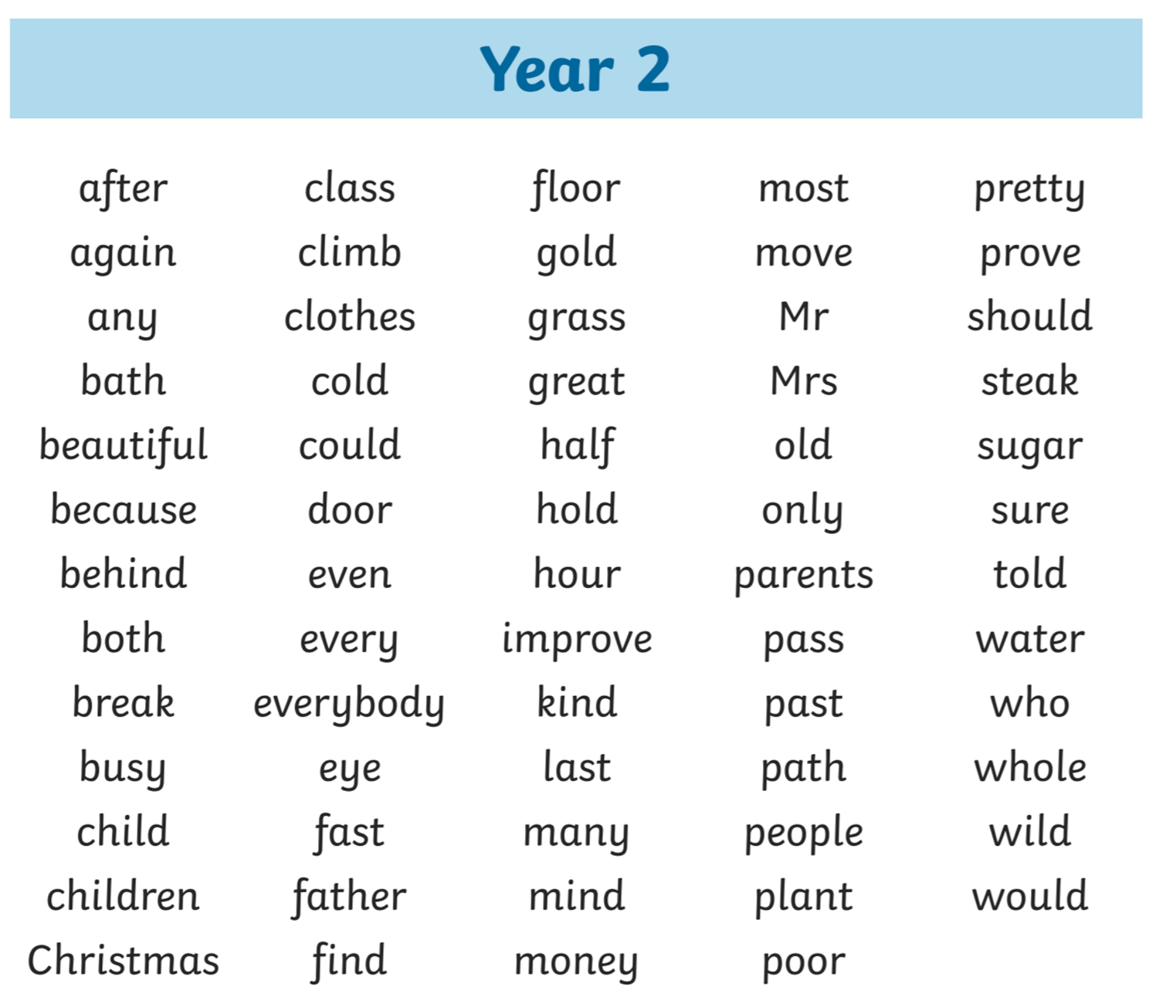

It is expected that children write in pencil, using a cursive joined style which will be practised during weekly handwriting lessons.

Speaking and Listening
Speaking and listening is an extremely important part of the curriculum. Our aim is to create a classroom environment where children feel confident to express their ideas and opinions without judgement. Equally, they are expected to listen to others with respect and consideration.

Mathematics
Across the school, we have adopted the Maths Mastery approach. It emphasises the importance of acquiring a deep, long-term, secure and adaptable understanding of the subject. Through the use of concrete resources, pictorial representations and abstract notation (which is often referred to as the C-P-A approach), children develop their mathematical fluency without resorting to rote learning and are able to solve non-routine maths problems without having to memorise procedures.

We fundamentally believe that, all pupils are entitled to and are capable of succeeding within maths. We endeavour to not only develop the mathematic skills and understanding required for later life, but also an enthusiasm and fascination about maths itself.

The curriculum is organised into units, beginning with concepts of number which are then utilised and built upon within all other areas. Concepts are taught in small increments with significant time spent on developing deep knowledge of the key ideas (i.e. number and place value, the four operations, as well as multiplication and division facts) that are needed to underpin future learning.

While Mathematics is taught mainly as a discrete subject, every effort is made to link maths with other areas of the curriculum.

Although this is subject to change, Maths within Year 2 is expected to be taught in the following order.

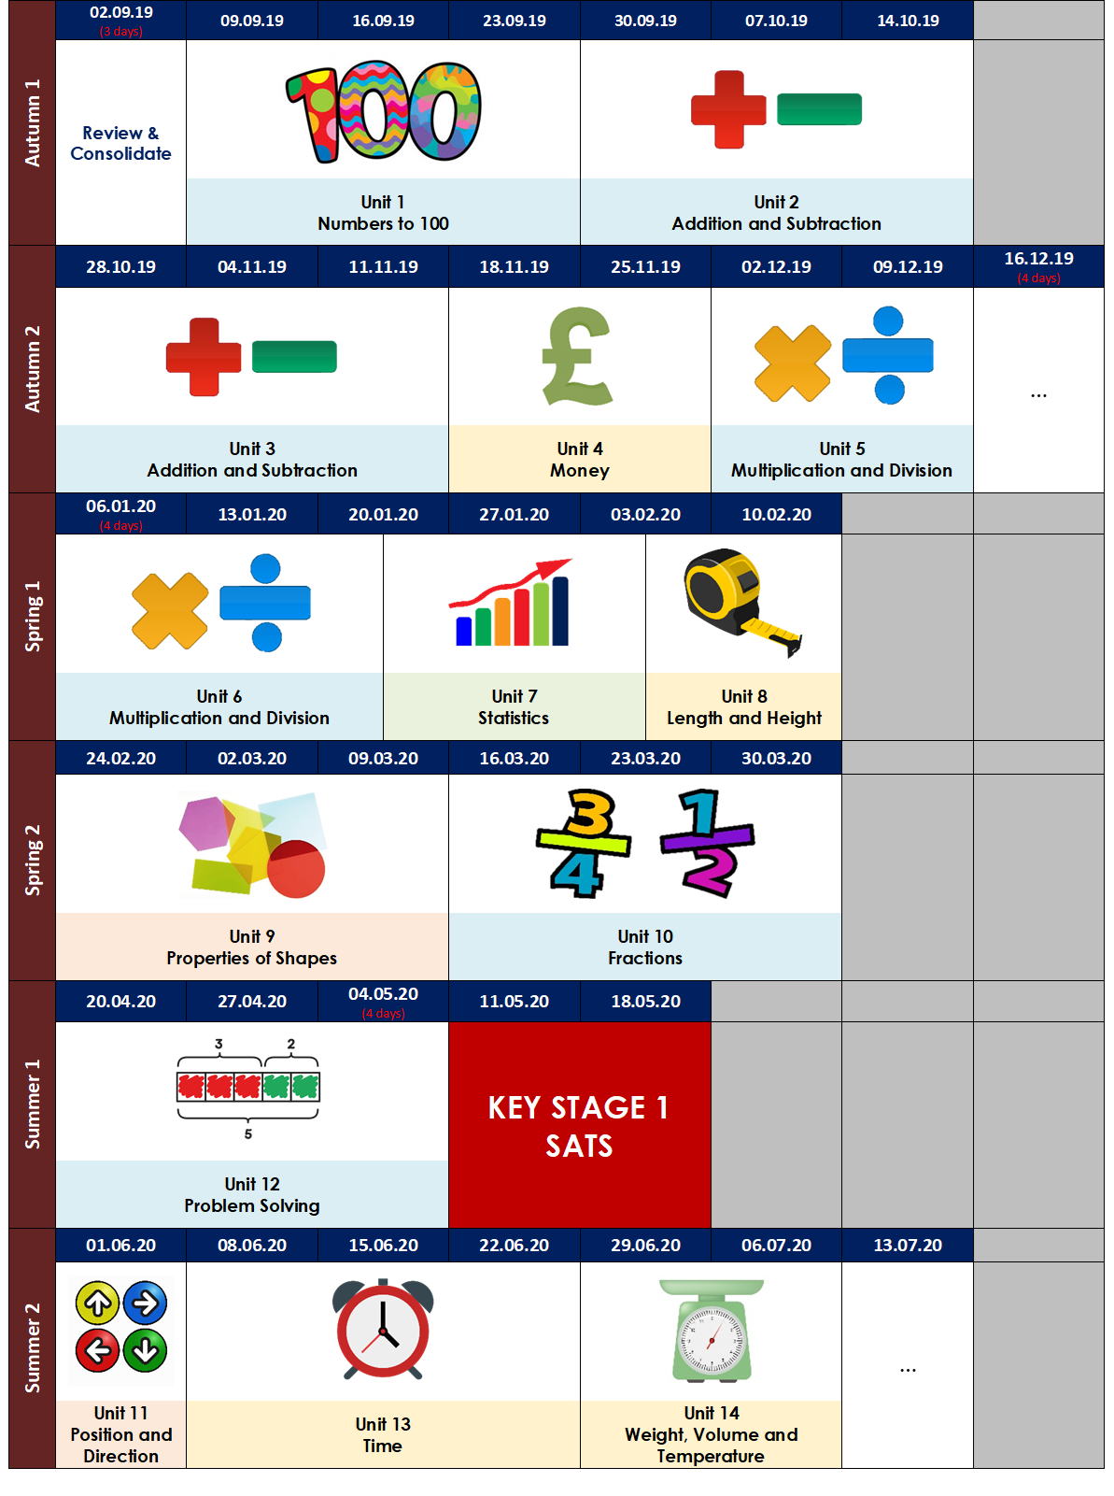
SATs
In May, Year 2 pupils sit national curriculum tests in English and Mathematics, commonly called SATs. The tests are a tool for teachers to help them measure your child’s performance and identify their needs as they move into Key Stage 2. They also allow teachers to see how your child is performing against national expected standards.

The tests can be taken any time during May and they are not strictly timed. Pupils may not even know they are taking them as they will be incorporated into everyday classroom activities.

Further information will be provided during a parents meeting which will take place during the Spring Term. There is no need for parents to do any extra preparation or test practice.

Physical Education (PE)
PE will be taught twice a week. It is important that your child has the correct kit. They will need: navy shorts, school tracksuit top and bottoms, red polo t-shirt, suitable sports shoes and a named PE bag. It is important that their PE kit is in school every day as lessons may be unexpectedly moved or a change of clothes might be required. Lessons may take place inside or outside depending on the weather conditions.

Although the days and times are subject to change, PE lessons will be taking place on Monday and Tuesday. Further information will be provided on the classroom door.

On the day of PE, children should wear their full school uniform to school. They will then change into their PE kit just before the lesson begins and out of their PE kit at the end, safely storing them within the classroom.

Music
Learning a musical instrument can be one of life’s greatest joys. Musical endeavour can lead to higher levels of self-confidence, self-motivation and self-discipline. If you would like your child to have the opportunity to receive instrumental tuition from a professional teacher, please enquire at the office (office@watlingparkschool.org.uk) for available spaces as well as the expected tuition fee.

Note: Children will require their own instrument to practice.

MFL
We offer Spanish as our Modern Foreign Language. This is taught by Mrs Lilywhite.

Trips and Visits
The impact of educational trips is an important element in developing a child’s knowledge and understanding of the world. They not only engage and stimulate curiosity, they also provide hands-on opportunities for children to see more abstract ideas discussed during lessons in reality. However, the school is unable to fund trips and visits, so if we do not receive enough payments from parents/carers, they will sadly be cancelled.

From September 2019, parents and carers will be informed about the expected cost of all trips and visits at the beginning of the academic year. You will be able to pay this as a one-off payment or in instalments. You may be charged for a small number of additional events, but we will aim to jeep this to a minimum.

Note: Being eligible for Free School Meals/Pupil Premium does NOT entitle you to free trips, visits or events. Please speak to the office for further advice or guidance.

Homework
Homework is used to reinforce or extend the work completed during lessons. Homework books are given out on Friday and are due back by the following Wednesday.

Each half term, a table containing a range of activities, linked to the current topic, are sent home. Each week your child will be asked to complete one activity of their choice, either by themselves or with your support. The stars at the top of each column gives a different level of challenge. Each child is asked to complete at least one three star challenge each half term.

Once an activity has been completed, parents/carers should sign and date the corresponding box. We also appreciate your feedback, so please indicate if your child has found any homework particularly challenging.

Guidelines to support your child with home learning:
• Little and often! Encourage your child to do a little bit of homework every day, so it is not left until the night before.
• Create the right atmosphere for learning. Choose a time when your child is not too tired or hungry. Remove or turn off all electrical gadgets.
• Have equipment ready to support their learning.
• Talk to your child; it will help deepen their understanding.
• Learn together! Do not be afraid to show them that even adults are still learning.

Reading
It is essential that your child continues to read aloud with you at home for at least 15 minutes per day. Each day, your child will be given the opportunity to select a book of their choice, at an appropriate level, to be taken home to share with an adult. Parents/Carers should ask questions about the text to further develop comprehension skills in addition to their understanding of vocabulary and content [Appendix B].

On average, a child within Year 2 should change their book at least 3 or 4 times per week.

Each time your child reads their book, you should record their progress within their reading diary by signing and dating the corresponding box along with writing a brief comment.

Reading for pleasure is also highly recommended and encouraged. See Appendix C for a list of recommended books which are age appropriate.
Children are also able to access online reading books through ‘Bug Club’. https://www.activelearnprimary.co.uk/login

Children within Year 2 would still benefit from shared reading before bedtime. This is when you read a book to them that is possibly above their current independent reading level.

Spelling
Each week, your child will be assigned spellings to practice and learn. This should be done at least 3 times per week for approximately 10 minutes. See Appendix D for a number of recommended strategies that could be used.

Maths
It is really important that your child develops a secure sense of number. Children with good number sense can:
- Manipulate numbers to make calculations easier, and are flexible in their approach.
- Assess the reasonableness of an answer, and routinely estimate answers before calculating.
- Identify connections and readily spot patterns in numbers.
- Use several approaches to calculate and solve problems.

To achieve this, it is vital that your child is able to fluently recall:
- The number bonds and related subtraction facts to 10, 20 and 100.
- Different ways of constructing numbers (i.e. 18 = 12 + 6 = 10 + 8 = …).
- The multiplication facts for the 2, 3, 5 and 10 times tables.
- A variety of mental strategies for adding and subtracting.

It is important that they practice the above concepts regularly at home (at least 3 times per week for approximately 10 minutes) so that they become embedded. This can be achieved whilst completing day to day activities like cooking, shopping and walking to school as well as by playing or completing a variety of games and puzzles (e.g. Uno, Rummikub, Sudoku, Monopoly etc.), including those invented by yourself or your child.
Children are also able to access online activities through ‘Mathletics’. https://www.activelearnprimary.co.uk/login

Other useful websites include:
- https://www.topmarks.co.uk/maths-games
- https://nrich.maths.org/
- https://www.mathsisfun.com/

Half Term Projects
During each holiday, every child within the school, will be given a project to complete. These projects are generally linked to either the time of year or specific event/concept.

General Information
Water Bottles
All children should have a water bottle with their name on in school every day.

Snack
Most days the children will be provided with a fruit snack. This will normally take place during morning playtime.

Birthday Treats
As a school, we will not cut up and/or distribute birthday cake, treats or party invitations! However, if you wish to do so, these can be distributed by yourself at the end of the day within the playground, provided there is enough for all children within the class. As with all food brought into school these must not include nuts.

Uniform
At Watling Park School, we pride ourselves on our ‘Look Smart, Think Smart’ philosophy and ask parents to support us in instilling this ethos in the children. Please see the ‘School Uniform Code’ for further information about requirements and expectations.

Our school uniform promotes a sense of pride in the school, looks smart and makes children feel equal to their peers in terms of appearance. Uniform should be worn with pride for the reason that everyone has the same smart appearance and celebrates belonging to the same school.

Please ensure that all uniform (including PE Kits, shoes and trainers) are clearly labelled with your child’s name and class. Items occasionally are misplaced by the children and, if clearly labelled, can be returned when found. ‘Iron on’ and ‘sew on’ name tags can be purchased online. Permanent marker pens and biro pens (which will need re-writing after a period of time) are a quick and effective way of labelling items.

Please Note:
- It is essential that children have a waterproof coat in school every day during the Autumn and Spring terms.
- Sensible, black girls’ boots can only be worn after October half term until February half term. Boots with fancy fur trims, jewels, high heels etc. are not acceptable.
- Wellington boots may be worn on snowy and icy days however school shoes should be provided in a bag to be worn in classrooms.
- Long hair should be tied back using only navy and black hair bands and/or clips.
- Watches and small stud earrings are the only permitted jewellery items, but they must be removed during PE, games or swimming.
- Nail varnish and make-up must not be worn.
- The school respects cultural dress and the uniform may be modified accordingly in consultation with the headteacher.

Parent Teacher Consultations
The first Parent Teacher Consultation in October has two functions - reviewing the start of term and setting up a dialogue with the class teacher. Where relevant, the teacher will indicate initial targets for your child and request your input.

The second Parent Teacher Consultation will be held in March. This meeting will provide further details of your child’s progress and attainment.

End of Year Report
At the end of the academic year, a written report on all subject areas will be sent out to parents. You will be given the opportunity to speak to the teacher briefly regarding this as well as to meet your child’s new teacher.

Parental Engagement and Events
Throughout the year, there will be many opportunities for you, as parents, to come in to school and take part in various activities or events. These may include workshops, special activity days, class performances and/or charity days (such as Red Nose Day) – further details will follow.

Attendance
If your child is absent for any reason please phone/email on the day by 8:30am, and follow this up with a letter which is a legal requirement giving the date and reason for absence.
Office email: office@watlingparkchool.org.uk

Please be sure that when your child says that they are unwell, they are truly feeling poorly. Many hours of learning time are missed due to children saying they feel ill when there may be other reasons for not wanting to come to school. Children often say they feel unwell, particularly at the start of a new term or new year group. During the Autumn and Winter months, children may feel colder than usual or be more difficult to rouse in the dark mornings. Quite often, children who come to school feeling slightly tired or unwell, pick up in the first 15 minutes of the day. Please speak to your class teacher if you are concerned at any point.

All adults in school are very experienced and will always monitor children and alert parents during the school day if they feel a child is not well enough to attend school.

Holidays
Children MUST avoid missing school for holidays. This absence will NOT be authorised and you may incur a fine. We understand that many special religious or cultural events fall inside the term time. A written request to the headteacher is required in order for religious or special/exceptional leave to be authorised. The form is available from the school office. Any child who is absent before or after any holiday period without official medical evidence will incur a fine (£120 per day per parent).

Punctuality
Please ensure your child is in school on time every morning. Many hours of learning are missed due to lateness. Learning begins at 8:45am. Your child will miss valuable learning experiences as well as social experiences. Please be aware that, often, a child’s self-esteem can fall as they feel uncomfortable entering a full classroom of children in the middle of learning. Regular lateness on the part of the parent may cause your child to say they are unwell, so they can stay at home and do not have to feel embarrassed.

At Watling Park School, you will be asked on a daily basis to provide reasons for lateness. Whilst we appreciate that at times there may be traffic incidents, this will not be counted as a reason for regular lateness. If you live a distance away from the school and drive or have to take public transport, we urge you to leave at least 10-15 minutes earlier.

Medical
Please advise us of medical appointments in advance.

Please ensure your contact details are updated in case of emergencies at school.

If your child is prescribed a medicine (by a pharmacist, dentist or doctor) please collect and complete ‘Form 1’ from the office before any medication can be administered in school (this includes creams). All medicine (with suitable spoon) must be labelled with your child’s name, in the original container and expiry date checked.

School Policies
Copies of up to date school policies can be accessed through the school website - www.watlingparkschool.org.uk

Watling Park’s Parent Association (WPPA)
WPPA will be established as the new parents’ organisation for the school. Its purpose will be to raise funds for local charities and the school along with organising social events for parents and children, as well as playing an important role in helping children and parents feel part of our school community.

The committee will meet on a regular basis through the course of the year. All members of the school community (such as parents/carers, staff, grandparents etc.) are welcome to attend these meetings.

Each year group will be represented on the committee by at least one parent. These parents will act as spokespeople and share information with other parents from your child’s class, so we hope you can get involved.

The first endeavour we will be raising money for, is to further enhance our playground to support the engagement and physical development of our children.

Appendix A – National Curriculum
Age related expectations for Lower Key Stage Two (Year 2)
Reading | Writing
Word reading  - Continue to apply phonic knowledge and skills as the route to decode words until automatic decoding has become embedded and reading is fluent.  - Read accurately by blending the sounds in words that contain the graphemes taught so far, especially recognising alternative sounds for graphemes.  - Read accurately words of two or more syllables that contain the same graphemes as  - Above.  - Read words containing common suffixes.  - Read further common exception words, noting unusual correspondences between spelling and sound and where these occur in the word.  - Read most words quickly and accurately, without overt sounding and blending, when they have been frequently encountered.  - Read aloud books closely matched to their improving phonic knowledge, sounding out unfamiliar words accurately, automatically and without undue hesitation.  - Re-read these books to build up their fluency and confidence in word reading.  Comprehension  - Listen to, discussing and expressing views about a wide range of contemporary and classic poetry, stories and non-fiction at a level beyond that at which they can read independently.  - Discuss the sequence of events in books and how items of information are related.  - Become increasingly familiar with and retelling a wider range of stories, fairy stories and traditional tales.  - Be introduced to non-fiction books that are structured in different ways.  - Recognise simple recurring literary language in stories and poetry.  - Discuss and clarifying the meanings of words, linking new meanings to known vocabulary.  - Discuss their favourite words and phrases.  - Continue to build up a repertoire of poems learnt by heart, appreciating these and reciting some, with appropriate intonation to make the meaning clear.  - Draw on what they already know or on background information and vocabulary provided by the teacher.  - Check that the text makes sense to them as they read and correcting inaccurate reading.  - Make inferences on the basis of what is being said and done.  - Answer and ask questions.  - Predict what might happen on the basis of what has been read so far.  - Participate in discussion about books, poems and other works that are read to them and those that they can read for themselves, taking turns and listening to what others say.  - Explain and discuss their understanding of books, poems and other material, both those that they listen to and those that they read for themselves. | Transcription - Spelling  - Segmenting spoken words into phonemes and representing these by graphemes, spelling many correctly.  - Learn new ways of spelling phonemes for which one or more spellings are already known, and learn some words with each spelling, including a few common homophones.  - Learn to spell common exception words.  - Learn to spell more words with contracted forms.  - Learn the possessive apostrophe (singular) [for example, the girl’s book].  - Distinguish between homophones and near-homophones.  - Add suffixes to spell longer words, including –ment, –ness, –ful, –less, –ly.  - Write from memory simple sentences dictated by the teacher that include words using the GPCs, common exception words and punctuation taught so far.  Transcription - Handwriting  - Form lower-case letters of the correct size relative to one another.  - Start using some of the diagonal and horizontal strokes needed to join letters and understand which letters, when adjacent to one another, are best left unjoined.  - Write capital letters and digits of the correct size, orientation and relationship to one another and to lower case letters.  - Use spacing between words that reflects the size of the letters.  Composition  - Write narratives about personal experiences and those of others (real and fictional).  - Write about real events.  - Write poetry.  - Write for different purposes.  - Plan or say out loud what they are going to write about.  - Write down ideas and/or key words, including new vocabulary.  - Encapsulate what they want to say, sentence by sentence.  - Evaluate their writing with the teacher and other pupils.  - Re-read to check that their writing makes sense and that verbs to indicate time are used correctly and consistently, including verbs in the continuous form.  - Proof-read to check for errors in spelling, grammar and punctuation [for example, ends of sentences punctuated correctly].  - Read aloud what they have written with appropriate intonation to make the meaning clear.  Vocabulary, Grammar and Punctuation  - Learn how to use both familiar and new punctuation correctly, including full stops, capital letters, exclamation marks, question marks, commas for lists and apostrophes for contracted forms and the possessive (singular).  - Use sentences with different forms: statement, question, exclamation, command.  - Expand noun phrases to describe and specify [for example, the blue butterfly].  - Use the present and past tenses correctly and consistently including the progressive form.  - Use subordination (using when, if, that, or because) and co-ordination (using or, and, or but).  - Use some features of written Standard English.

Age related expectations for Lower Key Stage Two (Year 2)
Mathematics | Science
Number – number and place value  - Count in steps of 2, 3, and 5 from 0, and in tens from any number, forward and backward.  - Recognise the place value of each digit in a two-digit number (tens, ones).  - Identify, represent and estimate numbers using different representations, including the number line.  - Compare and order numbers from 0 up to 100; use <, > and = signs.  - Read and write numbers to at least 100 in numerals and in words.  - Use place value and number facts to solve problems.  Number – addition and subtraction  - Use concrete objects and pictorial representations, including those involving numbers, quantities and measures.  - Apply their increasing knowledge of mental and written methods.  - Recall and use addition and subtraction facts to 20 fluently, and derive and use related facts up to 100.  - Add and subtract numbers using concrete objects, pictorial representations, and mentally, including: a two-digit number and ones, a two-digit number and tens, two two-digit numbers, and adding three one-digit numbers.  - Show that addition of two numbers can be done in any order (commutative) and subtraction of one number from another cannot.  - Recognise and use the inverse relationship between addition and subtraction and use this to check calculations and solve missing number problems.  Number – multiplication and division  - Recall and use multiplication and division facts for the 2, 5 and 10 multiplication tables, including recognising odd and even numbers.  - Calculate mathematical statements for multiplication and division within the multiplication tables and write them using the multiplication (×), division (÷) and equals (=) signs.  - Show that multiplication of two numbers can be done in any order (commutative) and division of one number by another cannot.  - Solve problems involving multiplication and division, using materials, arrays, repeated addition, mental methods, and multiplication and division facts, including problems in contexts.  Number – fractions  - Recognise, find, name and write fractions 1/3, 1/4, 2/4 and 3/4 of a length, shape, set of objects or quantity.  - Write simple fractions for example, 1/2 of 6 = 3 and recognise the equivalence of 2/4 and 1/2.  Measurement  - Choose and use appropriate standard units to estimate and measure length/height in any direction (m/cm); mass (kg/g); temperature (°C); capacity (litres/ml) to the nearest appropriate unit, using rulers, scales, thermometers and measuring vessels.  - Compare and order lengths, mass, volume/capacity and record the results using >, < and =.  - Recognise and use symbols for pounds (£) and pence (p); combine amounts to make a particular value.  - Find different combinations of coins that equal the same amounts of money.  - Solve simple problems in a practical context involving addition and subtraction of money of the same unit, including giving change.  - Compare and sequence intervals of time.  - Tell and write the time to five minutes, including quarter past/to the hour and draw the hands on a clock face to show these times.  - Know the number of minutes in an hour and the number of hours in a day.  Geometry – properties of shape  - Identify and describe the properties of 2-D shapes, including the number of sides and line symmetry in a vertical line.  - Identify and describe the properties of 3-D shapes, including the number of edges, vertices and faces.  - Identify 2-D shapes on the surface of 3-D shapes, [for example, a circle on a cylinder and a triangle on a pyramid].  - Compare and sort common 2-D and 3-D shapes and everyday objects. | Working Scientifically  - Ask simple questions and recognise that they can be answered in different ways.  - Observe closely using simple equipment.  - Performing simple tests.  - Identifying and classifying  - Using observations and ideas to suggest answers to questions.  - Gathering and recording data to help in answering questions.  Living things and their habitats  - Explore and compare the differences between things that are living, dead, and things that have never been alive.  - Identify that most living things live in habitats to which they are suited and describe how different habitats provide for the basic needs of different kinds of animals and plants, and how they depend on each other.  - Identify and name a variety of plants and animals in their habitats, including micro-habitats.  - Describe how animals obtain their food from plants and other animals, using the idea of a simple food chain, and identify and name different sources of food.  Plants  - Observe and describe how seeds and bulbs grow into mature plants.  - Find out and describe how plants need water, light and a suitable temperature to grow and stay healthy.  Animals, including humans  - Notice that animals, including humans, have offspring which grow into adults.  - Find out about and describe the basic needs of animals, including humans, for survival (water, food and air).  - Describe the importance for humans of exercise, eating the right amounts of different types of food, and hygiene.  Uses of everyday materials  - Identify and compare the suitability of a variety of everyday materials, including wood, metal, plastic, glass, brick, rock, paper and cardboard for particular uses.  - Find out how the shapes of solid objects made from some materials can be changed by squashing, bending, twisting and stretching.
Geometry – position and direction
- Order and arrange combinations of mathematical objects in patterns and sequences.
- Use mathematical vocabulary to describe position, direction and movement, including movement in a straight line and distinguishing between rotation as a turn and in terms of right angles for quarter, half and three-quarter turns (clockwise and anticlockwise).
Statistics
- Interpret and construct simple pictograms, tally charts, block diagrams and simple tables.
- Ask and answer simple questions by counting the number of objects in each category and sorting the categories by quantity.
- Ask and answer questions about totalling and comparing categorical data.
For further information, including the other subjects, follow the link below to access the national curriculum framework on the Department for Education website: https://www.gov.uk/government/publications/national-curriculum-in-england-framework-for-key-stages-1-to-4

Appendix B – Reading Comprehension Questions
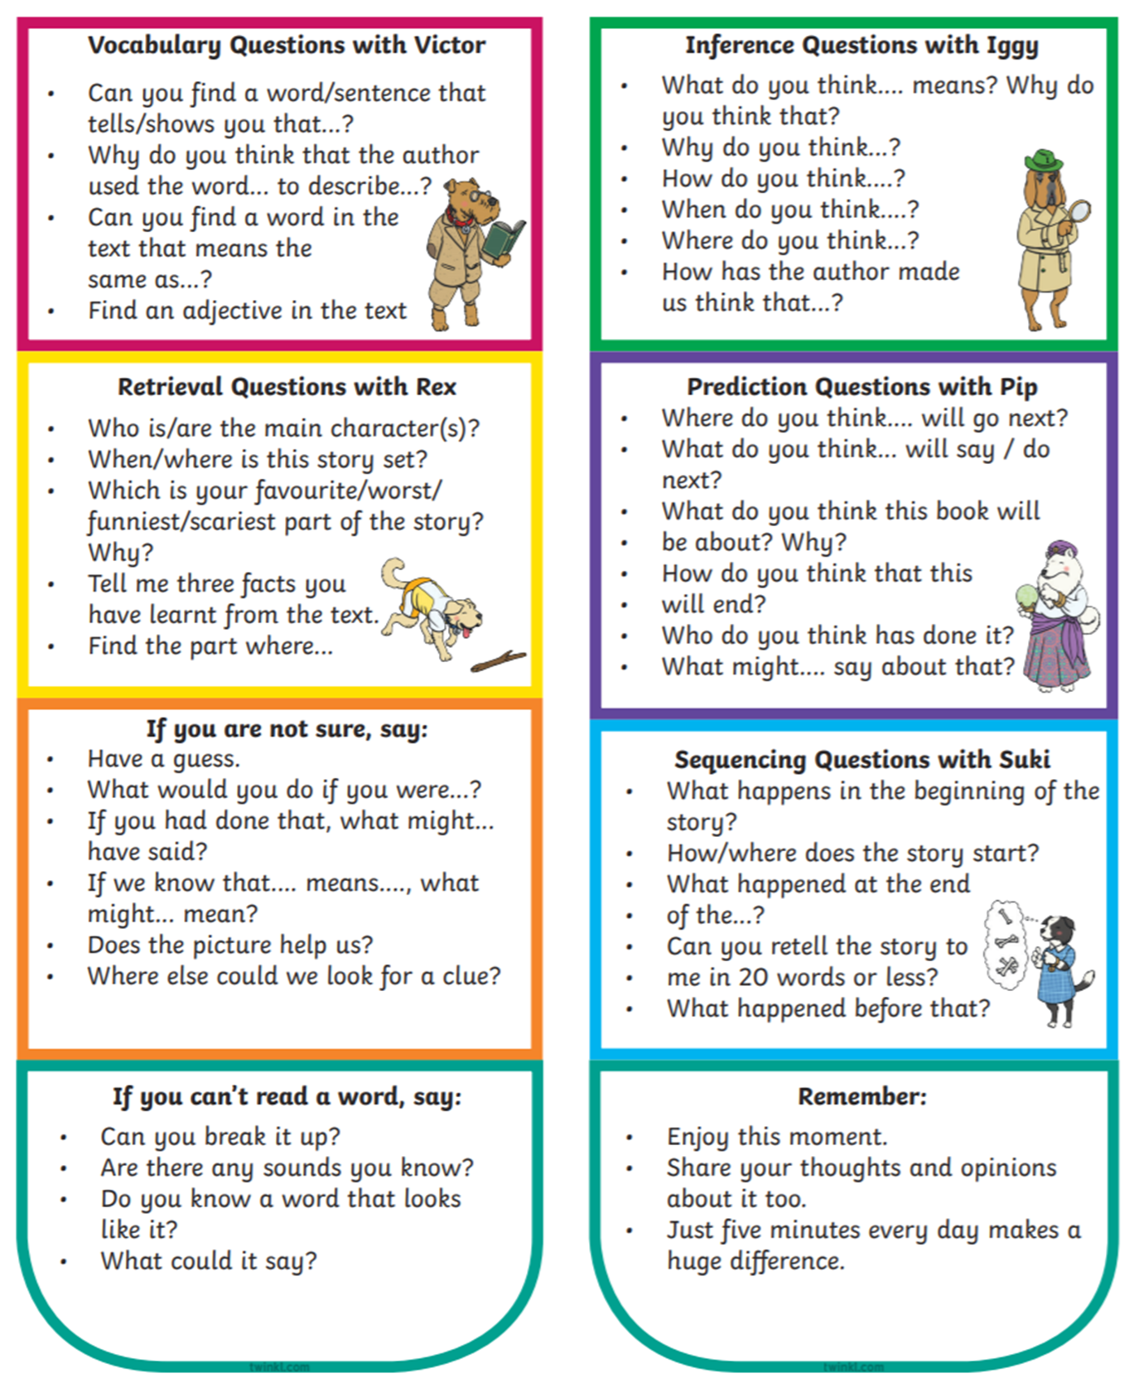

Appendix C – Year 2 Book List

The list includes a broad range of genres, from both classic and popular authors, and a wide variety of themes.

It is vital that your child reads regularly from texts that are appropriate to their reading and comprehension ability. This may be from the books on this list or from others.

Animals
•The Story of Babar, the Little Elephant – Jean De Brunhoff
•Mog Time Treasury: Six Stories about Mog the Forgetful Cat – Judith Kerr
•The Cat Who Lost its Purr – Michelle Coxon
•Choosing Crumble – Michael Rosen
•The Giraffe and the Pelly and Me – Roald Dahl
•Emily’s Legs – Dick King-Smith
•The Guard Dog – Dick King-Smith

Spooky/Mystery
•Jinnie Ghost – Berlie Doherty
•Gobbolino the Witch’s Cat – Ursula Williams
•The Dunderheads – Paul Fleischman
•The Tear Thief – Carol Ann Duffy
•How to Live Forever – Colin Thompson
•The Jolly-Rogers and the Ghostly Galleon – Jonny Duddle

Humour
•The Day the Crayons Quit – Drew Daywatt
•Clarice Bean, That’s Me – Lauren Child
•The Diary of a Killer Cat – Anne Fine
•Fungus the Bogeyman – Raymond Briggs
•Mrs Wobble the Waitress – Allan Ahlberg
•Pirate School: Just a Bit of Wind – Jeremy Strong
•Uncle Gobb and the Dread Shed – Michael Rosen
•Fluff the Farting Fish – Michael Rosen
•Clever Polly and the Stupid Wolf – Catherine Storr

Fantasy
•Mr Majeika – Humphrey Carpenter
•Beaver Towers – Nigel Hinton
•I Was a Rat! Or, the Scarlet Slippers – Philip Pullman
•Nim’s Island – Wendy Orr
•The Dragonsitter series – Josh Lacey
•The Magic Finger – Roald Dahl
•The Enchanted Wood – Enid Blyton

Adventure/Action
•The Adventures of Captain Underpants – Dav Pilkey
•The Man Whose Mother was a Pirate – Margaret Mahy
•Mr Wolf’s Pancakes – Jan Fearnley
•Press Here – Herve Tullet
•The Penderwicks – Jeanne Birdsall
•Frightened Fred – Peta Coplans
•Flat Stanley – Jeff Brown
•The Heart and the Bottle – Oliver Jeffers

Your local library is also an excellent resource for children’s books.

Further details and links for these can be found on the Literacy Trust website, which also has useful information on accessing books for different levels of readers - www.literacytrust.org.uk/familyreading

Appendix D – Spelling Strategies

