Welcome
to
Year 1
2019-20
Learn – Enjoy – Succeed

Mrs Whitcombe
Miss Dunbar

Head of Year: Mrs Whitcombe

Year 1 will be an exciting and challenging year for your child. Building on the skills they have gained within Reception, the emphasis will continue to be on cultivating independence and confidence along with developing the characteristics of effective learning. Within all subjects, the children will develop as confident, inquisitive learners in the knowledge that their work and contributions are highly valued.
The School Day
The school gates open at 8:35am each morning. The bell rings at 8:45am and lessons begin promptly. Parents are asked to leave their child in the playground as soon as the bell rings, allowing them to enter school on their own. This encourages independence and a quick and smooth transition into class. The gates will be closed at 8:50am.

At the end of the day, the school gates reopen at 3:25pm and the school day ends at 3:30pm. If you are unable to collect your child, please inform the office and/or class teacher, identifying who will be collecting. A password will be required to release your child to the nominated parent/adult which should be logged with the office.

Playtime
In Year 1, there is one playtime of 15 minutes at 10:45am in addition to a one-hour lunch break from noon. Outdoor equipment will be provided for the children to use. They may also have an afternoon playtime of 15 minutes, at the teacher’s discretion.

Lunch
In 2014, the Universal Infant Free School Meals (UIFSM) policy was introduced, stipulating that all children within Reception, Year 1 and Year 2 should be entitled to a healthy free school lunch. As a school, we expect all children within these year groups to take up the offer, unless there is a specific dietary requirement which prevents this.

The school kitchen provides us with a well-balanced nutritional menu; typically, this will be a hot meat or vegetarian meal with salad/vegetables, yoghurt and fruit as a dessert. We make every effort to meet the dietary requirements of children within school, special requirements must be shared with the office staff.

Children eating packed lunches take their lunch at the same time as the other children. Please ensure that they have a healthy lunch including a piece of fruit each day. Their food must not include any nuts, fizzy drinks or chocolate!

Note: Should your child wish to change from or to school dinners, you will need to provide the office with at least three weeks’ notice.

Extended Day Provisions
We provide additional services before and after the normal school day to support our busy families as well as help the children achieve their full potential. These services include a breakfast club, and a wide range of after-school activities. For further information about current availability, please contact the school office (office@watlingparkschool.org.uk) or the Extended Day Provision Lead, Miss Lulu (clubs@watlingparkschhol.org.uk).

Communication
Although the school has an open door policy, it is important that teachers are not distracted whilst supervising the children which includes when collecting and dismissing the children at the start and end of the day.

Minor concerns or messages may be shared quickly during this time, however, for longer or more confidential conversations, an appointment should be made, either directly with the member of staff or through the office.

Note: Parents should always contact the class teacher in the first instance before progressing to a more senior member of staff.

Whilst we make every effort to be proactive in informing parents about important events which have taken place during the day, this is not always immediately possible.
The School Curriculum
National Curriculum
Children will follow the age related expectations for Year 1 outlined within the National Curriculum [Appendix A].

Core Subjects | Foundation Subjects
English – Reading and Writing | Art and Design
Mathematics | Design and Technology
Science | Geography
 | History
 | Computing
 | Music
 | Physical Education (PE)

Schools are also required to teach RE (Religious Education) as well as PSHCE (Personal, Social, Health and citizenship Education). Children might often refer to ‘Jigsaw’ instead of PSHCE as we follow a whole school approach where each lesson is referred to as a piece of a bigger puzzle.

Cross Curricular Topics
Across the whole school, we take a cross-curricular approach to learning. Through a main topic, such as ‘Moon Zoom’, learning is put into context by the integration and coherent sequencing of knowledge and skills from all subject areas. This makes learning broad and balanced whilst developing enjoyment and motivation, higher order thinking and questioning skills, curiosity and independence.

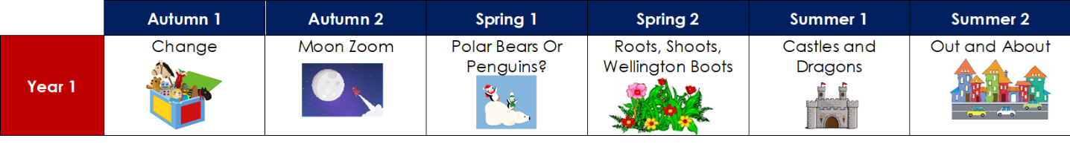
See the ‘Curriculum Overview’ and ‘Topic Webs’ (which are published at the beginning of each term) for further information about each topic taught.

English – Reading
During the school week, there will be multiple opportunities for your child to explore a range of different texts either through a class book linked to the topic, as part of their daily Read Write Inc. Phonics sessions, within guided reading sessions or individually during quiet reading.

English – Writing
Children are given a variety of opportunities to write in many different genres (i.e. narrative, recount, report, instructions, etc.) across the curriculum. They are encouraged to develop their work by writing consistently in full sentences, using more sophisticated grammar and descriptive language in order to engage the reader. The importance of accurate punctuation in all forms of writing is not only encouraged but expected.

Children continue to learn and apply spellings taught during Phonics in all writing across the curriculum, learning further ways to spell each sound. They learn a range of common spelling patterns as well as commonly misspelt words, as suggested in the National Curriculum (see below).

It is expected that children write in pencil, using a pre cursive joined style which will be practised during weekly handwriting lessons.

Speaking and Listening
Speaking and listening is an extremely important part of the curriculum. Our aim is to create a classroom environment where children feel confident to express their ideas and opinions without judgement. Equally, they are expected to listen to others with respect and consideration.

Phonics Screening Check
In June, all Year 1 pupils complete a Phonics Screening Check. It is a short, statutory assessment to ensure that children are making sufficient progress in the phonics skills to read words and are on track to become fluent readers who can enjoy reading for pleasure and for learning.

Your child will sit with the class teacher and will be asked to read 40 words aloud. The test normally takes a few minutes. If your child is struggling the teacher will stop the check. The check is carefully designed not to be stressful for your child.

Further information will be provided within the Spring Term.

Mathematics
Across the school, we have adopted the Maths Mastery approach. It emphasises the importance of acquiring a deep, long-term, secure and adaptable understanding of the subject. Through the use of concrete resources, pictorial representations and abstract notation (which is often referred to as the C-P-A approach), children develop their mathematical fluency without resorting to rote learning and are able to solve non-routine maths problems without having to memorise procedures.

We fundamentally believe that, all pupils are entitled to and are capable of succeeding within maths. We endeavour to not only develop the mathematic skills and understanding required for later life, but also an enthusiasm and fascination about maths itself.

The curriculum is organised into units, beginning with concepts of number which are then utilised and built upon within all other areas. Concepts are taught in small increments with significant time spent on developing deep knowledge of the key ideas (i.e. number and place value, the four operations, as well as multiplication and division facts) that are needed to underpin future learning.

While Mathematics is taught mainly as a discrete subject, every effort is made to link maths with other areas of the curriculum.

Although this is subject to change, Maths within Year 1 is expected to be taught in the following order.
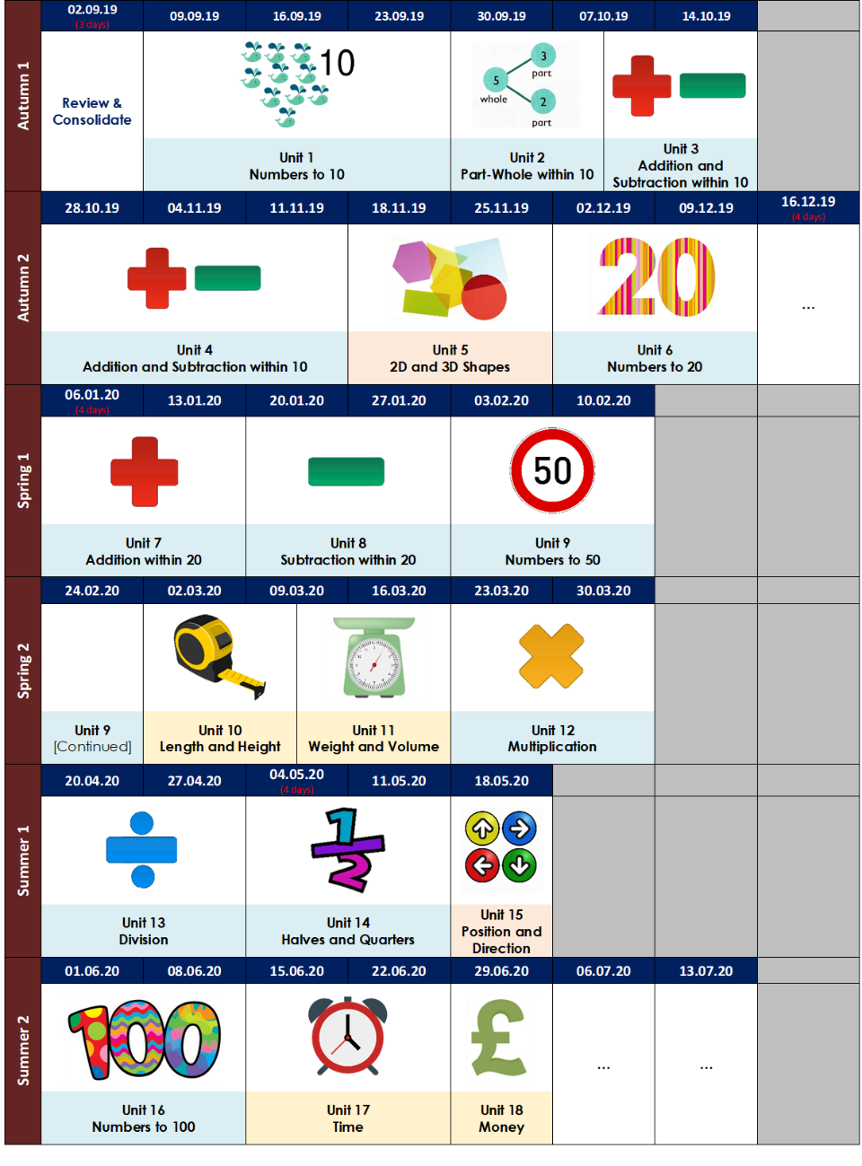

Physical Education (PE)
PE will be taught twice a week. It is important that your child has the correct kit. They will need: navy shorts, school tracksuit top and bottoms, red polo t-shirt, suitable sports shoes and a named PE bag. It is important that their PE kit is in school every day as lessons may be unexpectedly moved or a change of clothes might be required. Lessons may take place inside or outside depending on the weather conditions.

Although the days and times are subject to change, PE lessons will be taking place on Wednesday and Friday. Further information will be provided on the classroom door.

On Wednesday, children should wear their full PE kit to school, bringing their uniform within a bag. They will then change into their uniform after the PE lesson, safely storing them within the classroom. Whilst on Friday they should come to school within their full uniform and will then change into their PE kit just before the lesson. To ensure that the children are ready for the end of the day, they will wear their PE kit home.

Music
Learning a musical instrument can be one of life’s greatest joys. Musical endeavour can lead to higher levels of self-confidence, self-motivation and self-discipline. If you would like your child to have the opportunity to receive instrumental tuition from a professional teacher, please enquire at the office (office@watlingparkschool.org.uk) for available spaces as well as the expected tuition fee.

Note: Children will require their own instrument to practice.

MFL
We offer Spanish as our Modern Foreign Language. This is taught by Mrs Lilywhite.

Trips and Visits
The impact of educational trips is an important element in developing a child’s knowledge and understanding of the world. They not only engage and stimulate curiosity, they also provide hands-on opportunities for children to see more abstract ideas discussed during lessons in reality. However, the school is unable to fund trips and visits, so if we do not receive enough payments from parents/carers, they will sadly be cancelled.

From September 2019, parents and carers will be informed about the expected cost of all trips and visits at the beginning of the academic year. You will be able to pay this as a one-off payment or in instalments. You may be charged for a small number of additional events, but we will aim to jeep this to a minimum.

Note: Being eligible for Free School Meals/Pupil Premium does NOT entitle you to free trips, visits or events. Please speak to the office for further advice or guidance.

Homework
Homework is used to reinforce or extend the work completed during lessons. Homework books are given out on Friday and are due back by the following Wednesday.

Each half term, a table containing a range of activities, linked to the current topic, are sent home. Each week your child will be asked to complete one activity of their choice, either by themselves or with your support. The stars at the top of each column gives a different level of challenge. Each child is asked to complete at least one three star challenge each half term.

Once an activity has been completed, parents/carers should sign and date the corresponding box. We also appreciate your feedback, so please indicate if your child has found any homework particularly challenging.

Guidelines to support your child with home learning:
• Little and often! Encourage your child to do a little bit of homework every day, so it is not left until the night before.
• Create the right atmosphere for learning. Choose a time when your child is not too tired or hungry. Remove or turn off all electrical gadgets.
• Have equipment ready to support their learning.
• Talk to your child; it will help deepen their understanding.
• Learn together! Do not be afraid to show them that even adults are still learning.

Reading
It is essential that your child reads aloud with you at home for at least 15 minutes per day. Each day, your child will be given the opportunity to select a book of their choice, at an appropriate level, to be taken home to share with an adult. Parents/Carers should ask questions about the text to further develop comprehension skills in addition to their understanding of vocabulary and content [Appendix B].

On average, a child within Year 1 should change their book every day.

Each time your child reads their book, you should record their progress within their reading diary by signing and dating the corresponding box along with writing a brief comment.

Reading for pleasure is also highly recommended and encouraged. See Appendix C for a list of recommended books which are age appropriate.
Children are also able to access online reading books through ‘Bug Club’. https://www.activelearnprimary.co.uk/login

Children within Year 1 would also benefit from shared reading before bedtime. This is when you read a book to them that is possibly above their current independent reading level.

Spelling
Each week, your child will be assigned spellings to practice and learn. This should be done at least 3 times per week for approximately 10 minutes. See Appendix D for a number of recommended strategies that could be used.

Maths
It is really important that your child develops a secure sense of number. Children with good number sense can:
- Manipulate numbers to make calculations easier, and are flexible in their approach.
- Assess the reasonableness of an answer, and routinely estimate answers before calculating.
- Identify connections and readily spot patterns in numbers.
- Use several approaches to calculate and solve problems.

To achieve this, it is vital that your child is able to fluently recall:
- The number bonds and related subtraction facts to 10 and 20.
- Different ways of constructing numbers (i.e. 8 = 2 + 6 = 2 + 2 + 2 + 2 = …).
- The multiplication facts for the 2, 5 and 10 times tables.
- A variety of mental strategies for adding and subtracting.

It is important that they practice the above concepts regularly at home (at least 3 times per week for approximately 10 minutes) so that they become embedded. This can be achieved whilst completing day to day activities like cooking, shopping and walking to school as well as by playing or completing a variety of games and puzzles (e.g. Uno, Rummikub, Sudoku, Monopoly etc.), including those invented by yourself or your child.
Children are also able to access online activities through ‘Mathletics’. https://www.activelearnprimary.co.uk/login

Other useful websites include:
- https://www.topmarks.co.uk/maths-games
- https://nrich.maths.org/
- https://www.mathsisfun.com/

Half Term Projects
During each holiday, every child within the school, will be given a project to complete. These projects are generally linked to either the time of year or specific event/concept.

General Information
Water Bottles
All children should have a water bottle with their name on in school every day.

Snack
Most days the children will be provided with a fruit snack. This will normally take place during morning playtime.

Birthday Treats
As a school, we will not cut up and/or distribute birthday cake, treats or party invitations! However, if you wish to do so, these can be distributed by yourself at the end of the day within the playground, provided there is enough for all children within the class. As with all food brought into school these must not include nuts.

Uniform
At Watling Park School, we pride ourselves on our ‘Look Smart, Think Smart’ philosophy and ask parents to support us in instilling this ethos in the children. Please see the ‘School Uniform Code’ for further information about requirements and expectations.

Our school uniform promotes a sense of pride in the school, looks smart and makes children feel equal to their peers in terms of appearance. Uniform should be worn with pride for the reason that everyone has the same smart appearance and celebrates belonging to the same school.

Please ensure that all uniform (including PE Kits, shoes and trainers) are clearly labelled with your child’s name and class. Items occasionally are misplaced by the children and, if clearly labelled, can be returned when found. ‘Iron on’ and ‘sew on’ name tags can be purchased online. Permanent marker pens and biro pens (which will need re-writing after a period of time) are a quick and effective way of labelling items.

Please Note:
- It is essential that children have a waterproof coat in school every day during the Autumn and Spring terms.
- Sensible, black girls’ boots can only be worn after October half term until February half term. Boots with fancy fur trims, jewels, high heels etc. are not acceptable.
- Wellington boots may be worn on snowy and icy days however school shoes should be provided in a bag to be worn in classrooms.
- Long hair should be tied back using only navy and black hair bands and/or clips.
- Watches and small stud earrings are the only permitted jewellery items, but they must be removed during PE, games or swimming.
- Nail varnish and make-up must not be worn.
- The school respects cultural dress and the uniform may be modified accordingly in consultation with the headteacher.

Parent Teacher Consultations
The first Parent Teacher Consultation in October has two functions - reviewing the start of term and setting up a dialogue with the class teacher. Where relevant, the teacher will indicate initial targets for your child and request your input.

The second Parent Teacher Consultation will be held in March. This meeting will provide further details of your child’s progress and attainment.

End of Year Report
At the end of the academic year, a written report on all subject areas will be sent out to parents. You will be given the opportunity to speak to the teacher briefly regarding this as well as to meet your child’s new teacher.

Parental Engagement and Events
Throughout the year, there will be many opportunities for you, as parents, to come in to school and take part in various activities or events. These may include workshops, special activity days, class performances and/or charity days (such as Red Nose Day) – further details will follow.

Attendance
If your child is absent for any reason please phone/email on the day by 8:30am, and follow this up with a letter which is a legal requirement giving the date and reason for absence.
Office email: office@watlingparkchool.org.uk

Please be sure that when your child says that they are unwell, they are truly feeling poorly. Many hours of learning time are missed due to children saying they feel ill when there may be other reasons for not wanting to come to school. Children often say they feel unwell, particularly at the start of a new term or new year group. During the Autumn and Winter months, children may feel colder than usual or be more difficult to rouse in the dark mornings. Quite often, children who come to school feeling slightly tired or unwell, pick up in the first 15 minutes of the day. Please speak to your class teacher if you are concerned at any point.

All adults in school are very experienced and will always monitor children and alert parents during the school day if they feel a child is not well enough to attend school.

Holidays
Children MUST avoid missing school for holidays. This absence will NOT be authorised and you may incur a fine. We understand that many special religious or cultural events fall inside the term time. A written request to the headteacher is required in order for religious or special/exceptional leave to be authorised. The form is available from the school office. Any child who is absent before or after any holiday period without official medical evidence will incur a fine (£120 per day per parent).

Punctuality
Please ensure your child is in school on time every morning. Many hours of learning are missed due to lateness. Learning begins at 8:45am. Your child will miss valuable learning experiences as well as social experiences. Please be aware that, often, a child’s self-esteem can fall as they feel uncomfortable entering a full classroom of children in the middle of learning. Regular lateness on the part of the parent may cause your child to say they are unwell, so they can stay at home and do not have to feel embarrassed.

At Watling Park School, you will be asked on a daily basis to provide reasons for lateness. Whilst we appreciate that at times there may be traffic incidents, this will not be counted as a reason for regular lateness. If you live a distance away from the school and drive or have to take public transport, we urge you to leave at least 10-15 minutes earlier.

Medical
Please advise us of medical appointments in advance.

Please ensure your contact details are updated in case of emergencies at school.

If your child is prescribed a medicine (by a pharmacist, dentist or doctor) please collect and complete ‘Form 1’ from the office before any medication can be administered in school (this includes creams). All medicine (with suitable spoon) must be labelled with your child’s name, in the original container and expiry date checked.

School Policies
Copies of up to date school policies can be accessed through the school website - www.watlingparkschool.org.uk

Watling Park’s Parent Association (WPPA)
WPPA will be established as the new parents’ organisation for the school. Its purpose will be to raise funds for local charities and the school along with organising social events for parents and children, as well as playing an important role in helping children and parents feel part of our school community.

The committee will meet on a regular basis through the course of the year. All members of the school community (such as parents/carers, staff, grandparents etc.) are welcome to attend these meetings.

Each year group will be represented on the committee by at least one parent. These parents will act as spokespeople and share information with other parents from your child’s class, so we hope you can get involved.

The first endeavour we will be raising money for, is to further enhance our playground to support the engagement and physical development of our children.

Appendix A – National Curriculum
Age related expectations for Lower Key Stage Two (Year 1)
Reading | Writing
Word reading  - Apply phonic knowledge and skills as the route to decode words.  - Respond speedily with the correct sound to graphemes (letters or groups of letters) for all 40+ phonemes, including, where applicable, alternative sounds for graphemes read accurately by blending sounds in unfamiliar words containing GPCs that have been taught.  - Read common exception words, noting unusual correspondences between spelling and sound and where these occur in the word.  - Read words containing taught GPCs and –s, –es, –ing, –ed, –er and –est endings.  - Read other words of more than one syllable that contain taught GPCs.  - Read words with contractions [for example, I’m, I’ll, we’ll], and understand that the apostrophe represents the omitted letter(s).  - Read aloud accurately books that are consistent with their developing phonic knowledge and that do not require them to use other strategies to work out words.  - Re-read these books to build up their fluency and confidence in word reading.  Comprehension  - Listen to and discuss a wide range of poems, stories and non-fiction at a level beyond that at which they can read independently.  - Be encouraged to link what they read or hear read to their own experiences.  - Become very familiar with key stories, fairy stories and traditional tales, retelling them and considering their particular characteristics.  - Recognise and join in with predictable phrases.  - Learn to appreciate rhymes and poems, and to recite some by heart.  - Discuss word meanings, linking new meanings to those already known.  - Draw on what they already know or on background information and vocabulary provided by the teacher.  - Check that the text makes sense to them as they read and correcting inaccurate reading.  - Discuss the significance of the title and events.  - Make inferences on the basis of what is being said and done.  - Predict what might happen on the basis of what has been read so far.  - Participate in discussion about what is read to them, taking turns and listening to what others say.  - Explain clearly their understanding of what is read to them. | Transcription - Spelling  - Spell words containing each of the 40+ phonemes already taught.  - Spell common exception words.  - Spell the days of the week.  - Name the letters of the alphabet in order.  - Use letter names to distinguish between alternative spellings of the same sound.  - Use the spelling rule for adding –s or –es as the plural marker for nouns and the third person singular marker for verbs.  - Use the prefix un–.  - Use –ing, –ed, –er and –est where no change is needed in the spelling of root words [for example, helping, helped, helper, eating, quicker, quickest].  - Write from memory simple sentences dictated by the teacher that include words using the GPCs and common exception words taught so far.  Transcription - Handwriting  - Sit correctly at a table, holding a pencil comfortably and correctly.  - Begin to form lower-case letters in the correct direction, starting and finishing in the right place.  - Form capital letters.  - Form digits 0-9.  - Understand which letters belong to which handwriting ‘families’ (i.e. letters that are formed in similar ways) and to practise these.  Composition  - write sentences by saying out loud what they are going to write about.  - Compose a sentence orally before writing it.  - Sequence sentences to form short narratives.  - Re-read what they have written to check that it makes sense.  - Discuss what they have written with the teacher or other pupils.  - Read aloud their writing clearly enough to be heard by their peers and the teacher.  Vocabulary, Grammar and Punctuation  - Leave spaces between words.  - Join words and joining clauses using and.  - Begin to punctuate sentences using a capital letter and a full stop, question mark or exclamation mark.  - Use a capital letter for names of people, places, the days of the week, and the personal pronoun ‘I’.

Age related expectations for Lower Key Stage Two (Year 1)
Mathematics | Science
Number – number and place value  - Count to and across 100, forwards and backwards, beginning with 0 or 1, or from any given number.  - Count, read and write numbers to 100 in numerals; count in multiples of twos, fives and tens.  - Given a number, identify one more and one less.  - Identify and represent numbers using objects and pictorial representations including the number line, and use the language of: equal to, more than, less than (fewer), most, least.  - Read and write numbers from 1 to 20 in numerals and words.  Number – addition and subtraction  - Read, write and interpret mathematical statements involving addition (+), subtraction (–) and equals (=) signs.  - Represent and use number bonds and related subtraction facts within 20.  - Add and subtract one-digit and two-digit numbers to 20, including zero.  - Solve one-step problems that involve addition and subtraction, using concrete objects and pictorial representations, and missing number problems such as 7 = ? – 9.  Number – multiplication and division  - Solve one-step problems involving multiplication and division, by calculating the answer using concrete objects, pictorial representations and arrays with the support of the teacher.  Number – fractions  - Recognise, find and name a half as one of two equal parts of an object, shape or quantity.  - Recognise, find and name a quarter as one of four equal parts of an object, shape or quantity.  Measurement  - Compare, describe and solve practical problems for lengths and heights [for example, long/short, longer/shorter, tall/ short, double/half], mass/weight [for example, heavy/light, heavier than, lighter than], capacity and volume [for example, full/empty, more than, less than, half, half full, quarter], and time [for example, quicker, slower, earlier, later].  - Measure and begin to record lengths and heights, mass/ weight, capacity and volume, time (hours, minutes, seconds).  - Recognise and know the value of different denominations of coins and notes.  - Sequence events in chronological order using language [for example, before and after, next, first, today, yesterday, tomorrow, morning, afternoon and evening].  - Recognise and use language relating to dates, including days of the week, weeks, months and years.  - Tell the time to the hour and half past the hour and draw the hands on a clock face to show these times.  Geometry – properties of shape  - Recognise and name common 2-D and 3-D shapes, including: 2-D shapes [for example, rectangles (including squares), circles and triangles], and 3-D shapes [for example, cuboids (including cubes), pyramids and spheres].  Geometry – position and direction  - Describe position, direction and movement, including whole, half, quarter and three-quarter turns. | Working Scientifically  - Ask simple questions and recognise that they can be answered in different ways.  - Observe closely using simple equipment.  - Performing simple tests.  - Identifying and classifying  - Using observations and ideas to suggest answers to questions.  - Gathering and recording data to help in answering questions.  Plants  - Identify and name a variety of common wild and garden plants, including deciduous and evergreen trees.  - Identify and describe the basic structure of a variety of common flowering plants, including trees.  Animals, including humans  - Identify and name a variety of common animals including fish, amphibians, reptiles, birds and mammals.  - Identify and name a variety of common animals that are carnivores, herbivores and omnivores.  - Describe and compare the structure of a variety of common animals (fish, amphibians, reptiles, birds and mammals, including pets).  - Identify, name, draw and label the basic parts of the human body and say which part of the body is associated with each sense.  Everyday Materials  - Distinguish between an object and the material from which it is made.  - Identify and name a variety of everyday materials, including wood, plastic, glass, metal, water, and rock.  - Describe the simple physical properties of a variety of everyday materials.  - Compare and group together a variety of everyday materials on the basis of their simple physical properties.  Seasonal Changes  - Observe changes across the four seasons.  - Observe and describe weather associated with the seasons and how day length varies.
For further information, including the other subjects, follow the link below to access the national curriculum framework on the Department for Education website: https://www.gov.uk/government/publications/national-curriculum-in-england-framework-for-key-stages-1-to-4
Appendix B – Reading Comprehension Questions
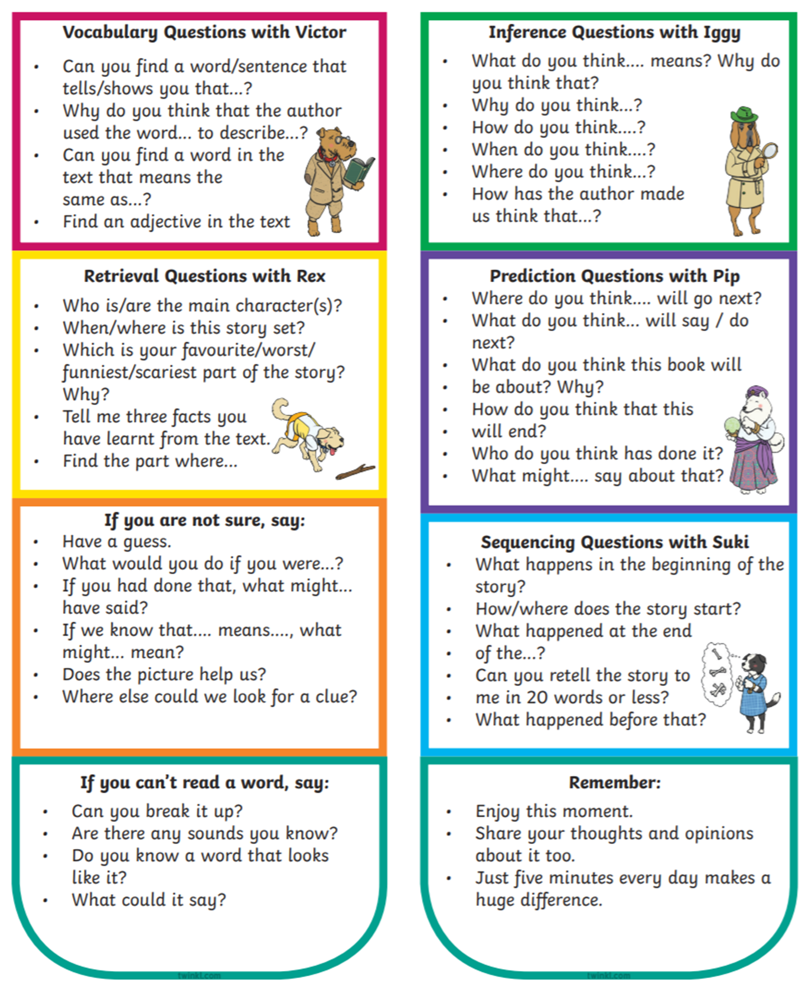

Appendix C – Year 1 Book List

The list includes a broad range of genres, from both classic and popular authors, and a wide variety of themes.

It is vital that your child reads regularly from texts that are appropriate to their reading and comprehension ability. This may be from the books on this list or from others.

•The Very Hungry Caterpillar – Eric Carle
•The Bad-Tempered Ladybird – Eric Carle
•We’re Going on A Bear Hunt – Michael Rosen
•Lullabyhullaba – Mick Inkpen
•Peace at Last – Jill Murphy
•Funny Bones – Allan Ahlberg
•Cops and Robbers – Allan Ahlberg
•The Gruffalo – Julia Donaldson
•The Smartest Giant in Town – Julia Donaldson
•The Paper Dolls – Julia Donaldson
•A Bear Called Paddington – Michael Bond
•A Lion in the Meadow – Margaret Mahy
•Hairy Maclary from Donaldson’s Diary by Lynley Dodd
•Owl Babies – Martin Waddell
•A Kitten Called Moonlught – Martin Waddell
•The Emperor of Absurdia – Chris Riddell
•There are Cats in this Book – Viviane Schwarz
•Mister Magnolia – Quentin Blake
•Mrs Armitage on Wheels – Quentin Blake
•Katie Morag’s Island Stories by Mairi Hedderwick
•My Friend Bear – Jez Alborough
•Avacado Baby – John Burningham
•The Tiger who came to Tea – Judith Kerr
•Meg and Mog – Helen Nichol
•Not Now Bernard – David McKee
•A Dark, Dark Tale – Ruth Brown
•Dogger – Shirley Hughes
•The Trouble with Jack – Shirley Hughes
•I Want My Hat Back – Jon Klassen
•The Dark – Lemony Snicket
•You Can’t Take an elephant on the Bus – Patricia Cleveland Peck
•Penguin – Polly Dunbar
•You Choose! – Pippa Goodhart
•Stanley’s Stick – Neale Layton
•What to Do If an Elephant Stands on Your Foot – Michelle Robin
•How to Wash a Woolly Mammoth – Michelle Robinson
•Dinosaurs in the Supermarket! – Timothy Knapman
•The Hodgeheg – Dick King-Smith
•The Cat in the Hat – Dr Seuss
•Charlie and Lola – Lauren Child
•Don’t Forget the Bacon – Pat Hutchins
•The Princess and the Pea – Minnie Grey
•The Whisperer – Nick Butterworth
•The Silver Swan – Michael Morpurgo
•The True Story of Three Little Pigs – Jon Scieszka
•The Grandad Tree – Trish Cooke
•Where’s My Teddy? – Jez Alborough
•My Friend Bear – Jes Alborough
•What If? – A H Benjamin
•Man on the Moon – Simon Bartram
•The Owl Who Was afraid of the Dark – Jill Tomlinson
•Out for the Count – Anne Fine

Your local library is also an excellent resource for children’s books.

Further details and links for these can be found on the Literacy Trust website, which also has useful information on accessing books for different levels of readers - www.literacytrust.org.uk/familyreading

Appendix D – Spelling Strategies

