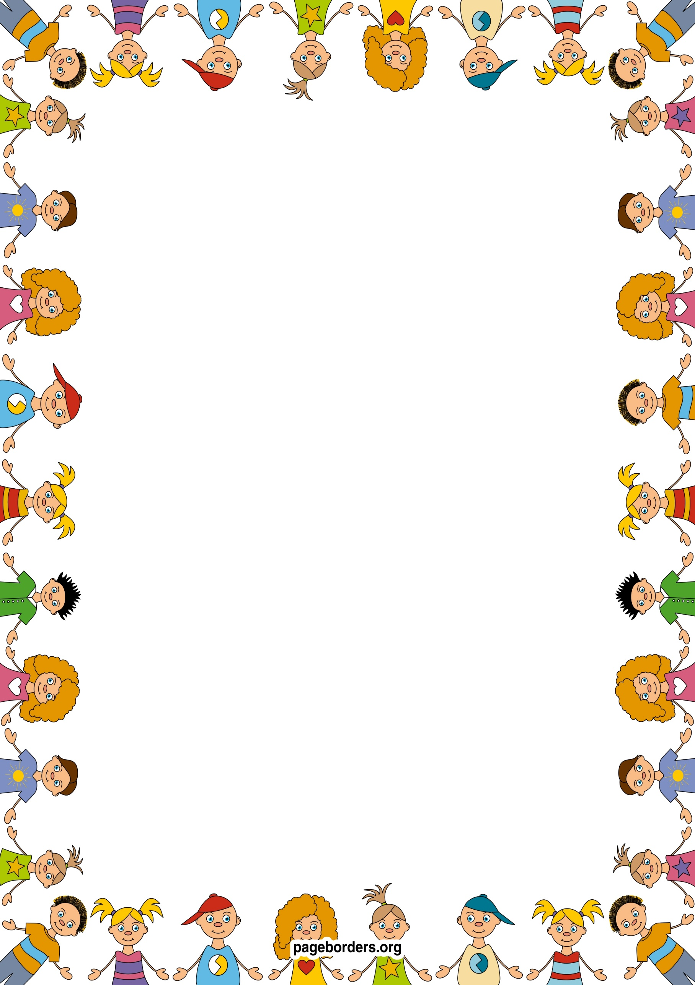

## Literacy (L)

* Learning to recognise and write my name.
* Learning to write familiar words such as mum, dad
* Writing about myself and my family.
* Learning to write for a purpose e.g. making lists, labelling pictures.
* Reading a range of fiction books
* Learning different sounds that letters make (phonics)
* Learning to blend sounds together to make simple words.

## Mathematics (M)

* Learning to count, recognize and order numbers to at least 10.
* Learning to match numbers to quantities of groups to at least 10.
* Learning to say the number one more/less than a given number up to 10.
* Learning to name and describe simple 2D.
* Sorting shapes and objects by colour and size
* Learning to create repeating patterns.
* Comparing myself, my friends and family and putting my findings into simple graphs and tables
* Ordering the events in my day.

Reception Autumn 1

Marvellous Me

## Expressive Arts & Design (EAD)

* Drawing pictures of myself using mirrors.
* Drawing pictures of my family
* Thinking about colours and using them appropriately in my pictures.
* Using a range of objects to print with e.g. shoes, hands
* Learning new songs to help me in my learning.
* Roleplaying in the home corner.
* Acting out stories with puppets.
* Using a range of materials to make collages and models.

**Personal Social Emotional Development (PSED)**

* Creating class rules with my friends.
* Participating in turn taking games
* Trying out new activities independently and select resources independently.
* Dressing and undressing independently for P.E
* Learning routines of the school day
* Learning to think about the feelings of others
* Learning and talking about my family and other people who are important to me

## Communication and Language (CL)

* Learning to talk about myself using describing words such as tall, short.
* Imagining and recreating roles in real life family situations and fictional stories.
* Asking questions to get to know my friends in my new class.
* Talking about my family
* Thinking about sequence of events in stories and saying what happened in the beginning, middle and end.

## Understanding the World (UW)

* Using digital cameras to take photos of my friends
* Using a computer to help me in my learning.
* Using all five senses to investigate area around them
* Recognizing similarities and differences between each other
* Going on local walks around the school.
* Learning about different parts of the body.

## Physical Development (PD)

* Playing ring games
* Using tools safely
* Learning about how to be healthy
* Describing the changes my body after being active.
* Moving with control and co-ordination over, under, through various small apparatus.
* Using a range of small and large equipment.
* Using a range of malleable materials in my play.