Reading
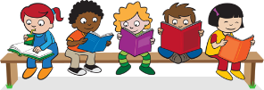
Read every day for at least 15 minutes, recording your progress and completing the comments section within your reading diary. Discuss each book with an adult, answering some of the questions provided on the reading guidance.
Reading diaries must be signed by your parent/carer before the book may be changed.
Spelling
Practise the spellings that are kept in the cover of your home learning book. Do this at least 2 to 3 times per week using one or more of the strategies listed on the ‘Strategies List’. Guidance can be found on the home learning section of the website.
Number Facts
 | We have invested in ‘Mathletics’, an online maths platform. Log on at least 3 times each week to practise Year 2 maths skills and have fun at the same time! You can practise multiplication and division facts for the 2, 5 & 10 times tables.
Topic
Each week choose and complete a different activitiy from those provided within the table. These activties are based upon the current topic, ‘Land Ahoy’, and will support and extend your learning. Try completing at least one ‘Three Star Challenge’ each half term. | 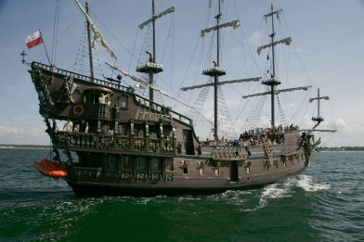
Other
If necessary, occasional additional tasks may be provided to further support your progress.
See the website for parent/carer guidance on how best to support at home along with additional activity suggestions.
Please read the home learning for this term and ask your class teacher if you have any questions or queries.

Topic:
Land Ahoy!
I enjoy reading, writing and speaking. | Tell someone at home about our story, ‘Pirates Love Underpants’. What was their favourite part?  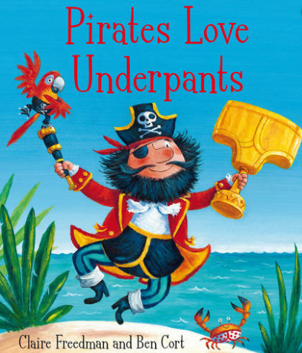 | Go to the library and take out a book about a famous sea explorer. Write 3 key things that you learn. | Prepare a presentation about a sea explorer. Be prepared to talk to the class for 3-5 minutes about it. Please let your teacher know if you have chosen this so that we can make time in the day.
I enjoy working with numbers as well as working scientifically. | Make a list of different materials. Can you sort them into different categories? | Go on a walk around the park or your garden and make a treasure map. Make sure you include a key to help the pirates find the treasure!  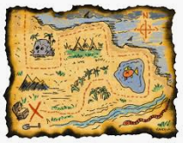 | Research and record different materials at home that float and sink
I enjoy painting, drawing and visualising. | Make a picture of a ship.  You could make a collage, painting or drawing. Label the parts of the ship. | Draw a flag of a country in the United Kingdom. You can use colours or paints to decorate the flag. | Make a model of a treasure chest. You can stick items of treasure inside. Ask an adult first!
I enjoy being active and hands-on. | Make a map of your house. Give someone directions using North, East, South and West. See where they end up.  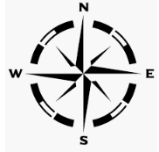 | Use clay or playdough to make a model ship or boat. You could include material for the sails. | Use objects around the house to recreate the story of ‘Pirates Love Underpants’.

Parents/carers: For each activity, once completed, write the date and sign/initial below the activity description. Feel free to write a comment.

