Reading
Read every day for at least 15 minutes, recording your progress and completing the comments section within your reading diary. Discuss each book with an adult, answering some of the questions provided on the reading guidance.
Reading diaries must be signed by your parent/carer before the book may be changed.
Spelling
Practise the provided spellings at least 2 to 3 times per week using one or more of the strategies listed on the ‘Strategies List’.
Number Facts
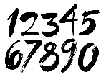 | Develop your knowledge of multiplication facts using the activities provided on ‘Times Tables Rock Stars’. Each week you will be assigned a different times table to practise.
Topic
Each week choose and complete a different activitiy from those provided within the table. These activties are based upon the current topic ‘Extreme Earth’ and will support and extend your learning. Try completing at least one ‘Three Star Challenge’ each half term. |  | 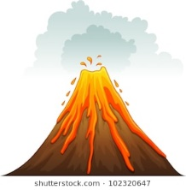
Other
If deemed necessary, occasional additional tasks may be provided to further support your progress.
See the website for parent/carer guidance on how best to support at home along with additional activity suggestions.

Extreme Earth
I enjoy reading, writing and speaking. | Look at a picture of a volcano. Make a list of 10 interesting adjectives to describe the volcano. | Download a picture of an erupting volcano, and write a descriptive paragraph. | Write a story about a volcano erupting in Edgware.
I enjoy working with numbers as well as working scientifically. | Make a rock/pebble tower, how many can you stack before it collapses? | Find 5 rocks, use a ruler to measure their height and width in centimetres. Record the information in a table. | Research 10 volcanos. Order them according to height (in metres).
I enjoy painting, drawing and visualising. | Paint or draw a picture of a volcano. | Create a rock collage using a number of different rocks found within your garden or local park. | Find a large, smooth rock and decorate it. Then hide it somewhere in public near where you live.  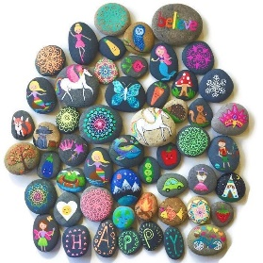
I enjoy being active and hands-on. | Make some slime which looks like lava. | Find and sort a selection of different rocks from your garden or local park. How many different ways can you sort them? | Build a ‘volcano’ from items found outside.

Parents/carers: For each activity, once completed, write the date and sign/initial below the activity description. Feel free to write a comment.

