Reading
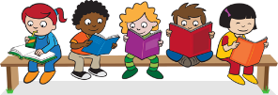
Read every day for at least 15 minutes, recording your progress and completing the comments section within your reading diary. Discuss each book with an adult, answering some of the questions provided on the reading guidance.
Reading diaries must be signed by your parent/carer before the book may be changed.
Spelling
Practise the spellings that are kept in the cover of your home learning book. Do this at least 2 to 3 times per week using one or more of the strategies listed on the ‘Strategies List’. Guidnace can be found on the home learning section of the website.
Number Facts
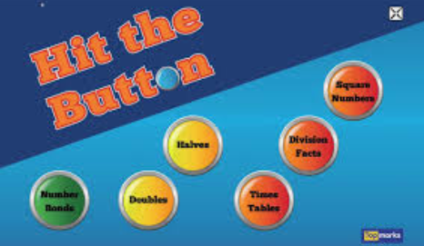 | Develop your knowledge of the 2, 5 and 10 times tables and division facts. Use a game on top marks called ‘Hit the button’ to help. See our home learning page of the website for the link.
Topic
Each week choose and complete a different activitiy from those provided within the table. These activties are based upon the current topic, ‘Africa’, and will support and extend your learning. Try completing at least one ‘Three Star Challenge’ each half term. | 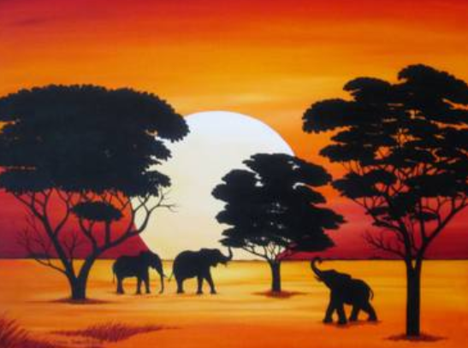
Other
If necessary, occasional additional tasks may be provided to further support your progress.
See the website for parent/carer guidance on how best to support at home along with additional activity suggestions.

Topic:
Africa
I enjoy reading, writing and speaking. | Read a book about African animals and write down 5 facts.  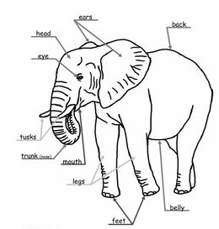 | 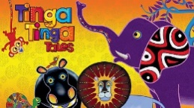  Read or watch a ‘Tinga Tinga’ tale. CBBC made some great cartoons! Can you tell the story off by heart? Tell it to your family and friends. | Research an African animal and make a poster about it! Can you include pictures or a labelled diagram?
I enjoy working with numbers as well as working scientifically. | Choose an African animal that you know. Find some information about it and describe it to your family. You can use books or the internet to help you.  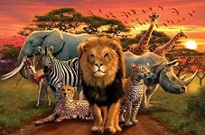 | 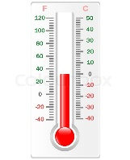  Many places in Africa are very hot. Use a thermometer to measure the hottest place in your house. | Write a list of lots of animals. Can you sort them into groups by their habitat?  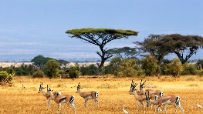
I enjoy painting, drawing and visualising. | Draw pictures of African animals. You can use the internet to help you. Which ones are harder to draw? Draw your picture 3 times, trying to make it even better each time! | Make a collage of an African animal. You could choose a lion, an elephant or a snake. Use different materials and stick them down to create your image.  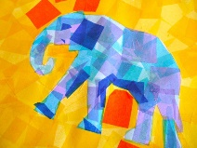 | Make up your own story about a lion. Instead of writing it, draw it as a cartoon or a story map.
I enjoy being active and hands-on. | Find a recipe for some African food and make it with your parents or carers!  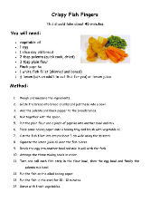 | Play a game of animal charades. Act out an African animal and ask your family to guess which one you are! | Visit the library, use the internet or books to find out about African huts. Make one out of recycled cardboard boxes and take a picture! Think about materials you could use to make the pointed roof shape.

Parents/carers: For each activity, once completed, write the date and sign/initial below the activity description. Feel free to write a comment.

