Year 1 and 2 Spelling and Reading Word Sheets

These sheets are very useful for helping to read and spell common words and words which follow Year 2 spelling patterns.
How to use the sheets:
Reading: Do maybe half a page at a time, or try the whole page. Ask the child to read each word, and if they can, let them colour in one triangle of that word. Help them to use phonics to try words they don’t know, and talk about the tricky parts of the word. Hopefully, over time the child will be able to colour in more and more triangles. Keep going until all 4 triangles are coloured for a word, then you can skip that one and concentrate on the more difficult ones.
they

Spelling: Use in much the same way as for reading, only this time don’t show the child the word, just ask them to try to spell it on a separate piece of paper. This time you can maybe tick one triangle If they spell it right. Carry on over a number of sessions until all the words have a tick in all of the triangles. Remember, it will take many practices until they have learnt the words well.

they

A little at a time works best! We suggest 5 minutes at a time.
It is very important that your child does not feel under pressure when learning spelling so please make it as fun as possible. They also need to feel proud of their achievements, so celebrate when they learn new words.

Please turn over to see some ideas for how to practice spellings.

Strategies for practising spellings:
Step it out! | Bath-time | Torch-writing
Learn the letters in the correct order by saying the letter names. Then walk around the room, spelling the word aloud, saying one letter name on each step. | Write it in the bubble in the bath! | Write the words on the wall with a torch.  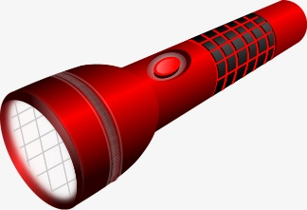
Back-writing | Magnetic letters | Headlines
Get them to write the words on you back and guess what they are writing.  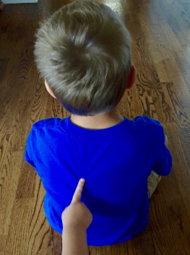 | Spell the words with magnetic letters on the fridge.  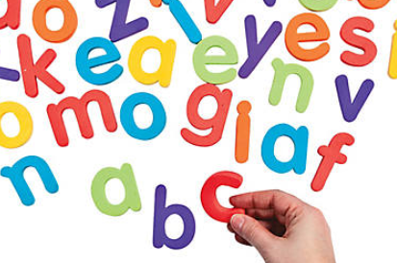 | Cut the letters out of a newspaper and put them in the correct order.  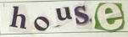
Backwards words | Rainbow words | Pyramids
Write it forwards, then write it backwards!  home emoh | 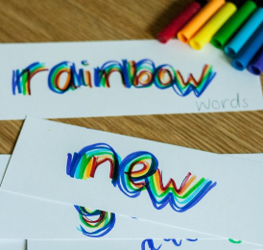 | s  so  som  some
Dot-to-dot | Foam-writing | Playdough
Write the words using dots. Then connect the dots you’ve drawn with a coloured pencil. | 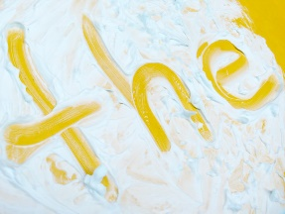 | 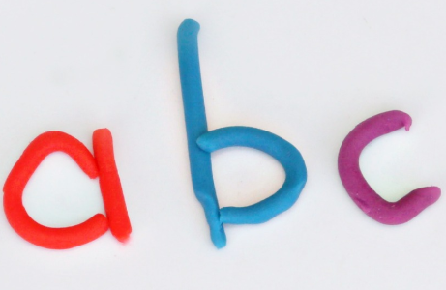
Beads | Silly sentences | Spelling catch
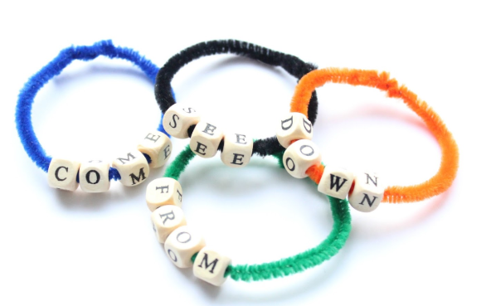 | Write a silly sentence using your spelling word.  My cat wears a hat when she goes outside. | Each time you throw the ball, say the next letter name. 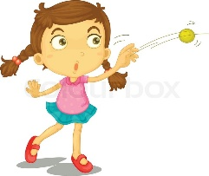
Kids doodle app | Twinkl spell pop app | Spelling shed app
Draw and write the spellings in a fun and colourful way. | 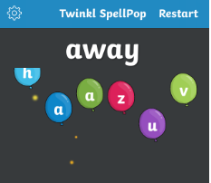  Pop the bubbles to spell words from the year 1 and 2 national curriculum. | 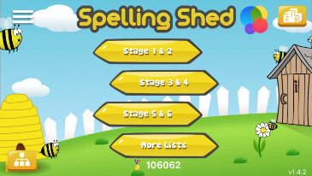  App featuring over 2000 words from the national curriculum.

