Friday 11th January 2019
New Homework Arrangements
Guide for Parents/Carers
Dear Parent/Carers,

Today your child/ren will bring homework in a slightly new format.

Reading and Spelling homework remains the same. There will be a termly focus for Mental Maths homework. Online activities and games to support homework can be found on the
Homework Page on the school website.

A new addition to the homework arrangements:
Topic homework – A table of activities will be sent home each half term with a range of activities for your child to choose from and complete either by themselves or with your support. These activities will usually be quite practical and fun things for them to help reinforce or extend the learning they are or will be doing in class.

Each week your child will be asked to choose and complete one activitiy from the table. These activties are based upon your child’s current topic and will support and extend their learning and skills in different ways.

The stars at the top of the columns gives a different level of challenge:

Once the activity is completed, please sign and date below the activity description.
For example:

The children are asked to try to complete at least one three star challenge each half term. Home learning books will still need to be returned to school each Wednesday.

The new homework format has been explained to the children in school, so ask them to tell
you how it works and what they are expected to do.

If you have any further questions, please arrange a time to meet with your class teacher
who will be happy to explain the system to you.

We look forward to seeing the amazing learning that the children produce!

Friday 11th January 2019
New Homework Arrangements

Today your child will bring homework in a slightly new format.
Reading and spelling remain the same | 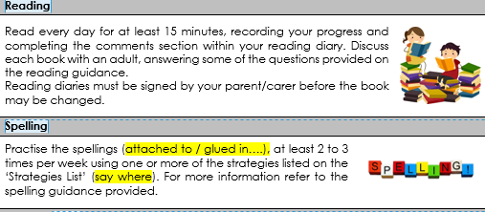
There will be a termly focus for Mental Maths homework. Online activities and games to support homework can be found on the  Homework Page on the school website. | 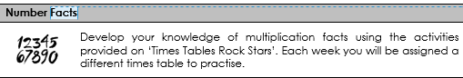
Topic homework - Each week your child needs to choose and complete one activitiy from the table. Once the activity is completed, please sign and date below the activity description. | 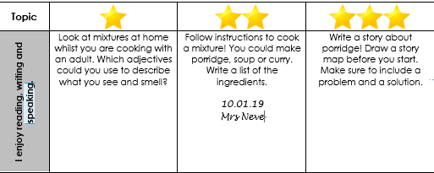
The stars at the top of the columns gives a different level of challenge:
1 = easiest; 3 = most challening/time consuming.

The children are asked to try to complete at least one three star challenge each half term.

The new homework format has been explained to the children in school, so ask them to tell
you how it works and what they are expected to do.

If you have any further questions, please arrange a time to meet with your class teacher
who will be happy to explain the system to you.

Thankyou,

Watling Park Staff

