Year 3 Homework |  | Due: Wednesday 12th December 2018
Reading: Please continue to read every day for at least 15 minutes, recording your progress and completing the comments section within your reading diary. Reading diaries must be signed by your parent/carer before the book can be changed.
Record the answers to the following questions in your reading diary. What did you like about the book? Why? What didn’t you like? How could it be improved?
Spelling: Practise the following at least 3 times for 10 minutes:
league | rogue | fatigue | unique | antique
Use one or more of the strategies listed on the ‘Strategies List’ located on the inside back cover.
English/Topic: Write a fact-file describing your favourite facts about the Romans. Choose 3 of these headings for structure: Gladiators, Homes, Towns, Roads, Food, Army. |  |  |  | 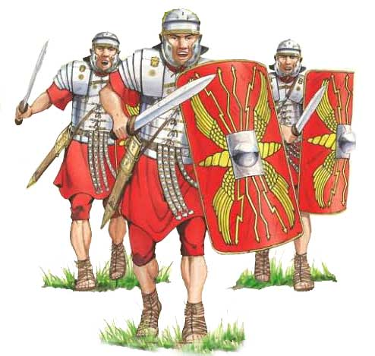
Support: Use www.kidrex.org to help with online research.
Challenge: Choose your own headings and describe the impact it had on Britain.
Maths: Complete the multiplication worksheet.
Support: Work with an adult. Use counters or objects to help calculate.
Challenge: Write a set of instructions for the multiplication column method.
Number Facts: Practise the multiplication and division facts for the 4 times table. How many questions can you answer in 1 minute? Log in to https://ttrockstars.com/ with your login to engage with the times-table challenges.
Outdoor Learning: Go on a nature walk. Take a photo of your favourite view. How has your local environment changed over the last month?
Next Week’s Learning:
English: We will be writing recipes in preparation for our Roman feast. We will also be learning how verbs change, depending on the tense used. | Maths: We will be learning how to construct and read picture and bar graphs. |  | Topic: We will be planning for our feast, including preparing the food! Parents/Carers are welcome to join us (Thursday 13th December @ 2:30).
Parent/Carer Comment:

Child comment:

