Holiday Home Learning: December 2018
Create a project about a building of your choice.
For example, you could choose your house, your place of worship or a building you have visited on a holiday.

You could present your project in different ways. Models, pictures, information posters and booklets are all great ideas.

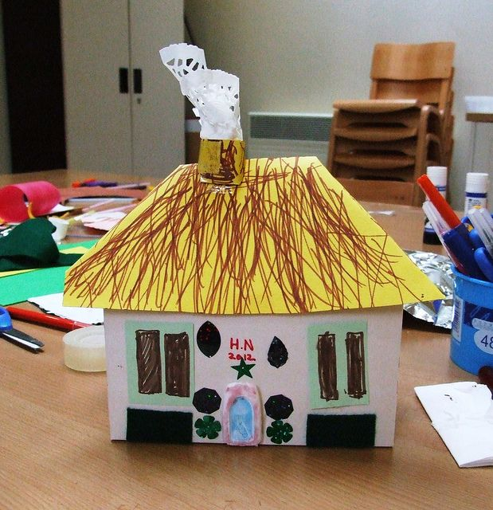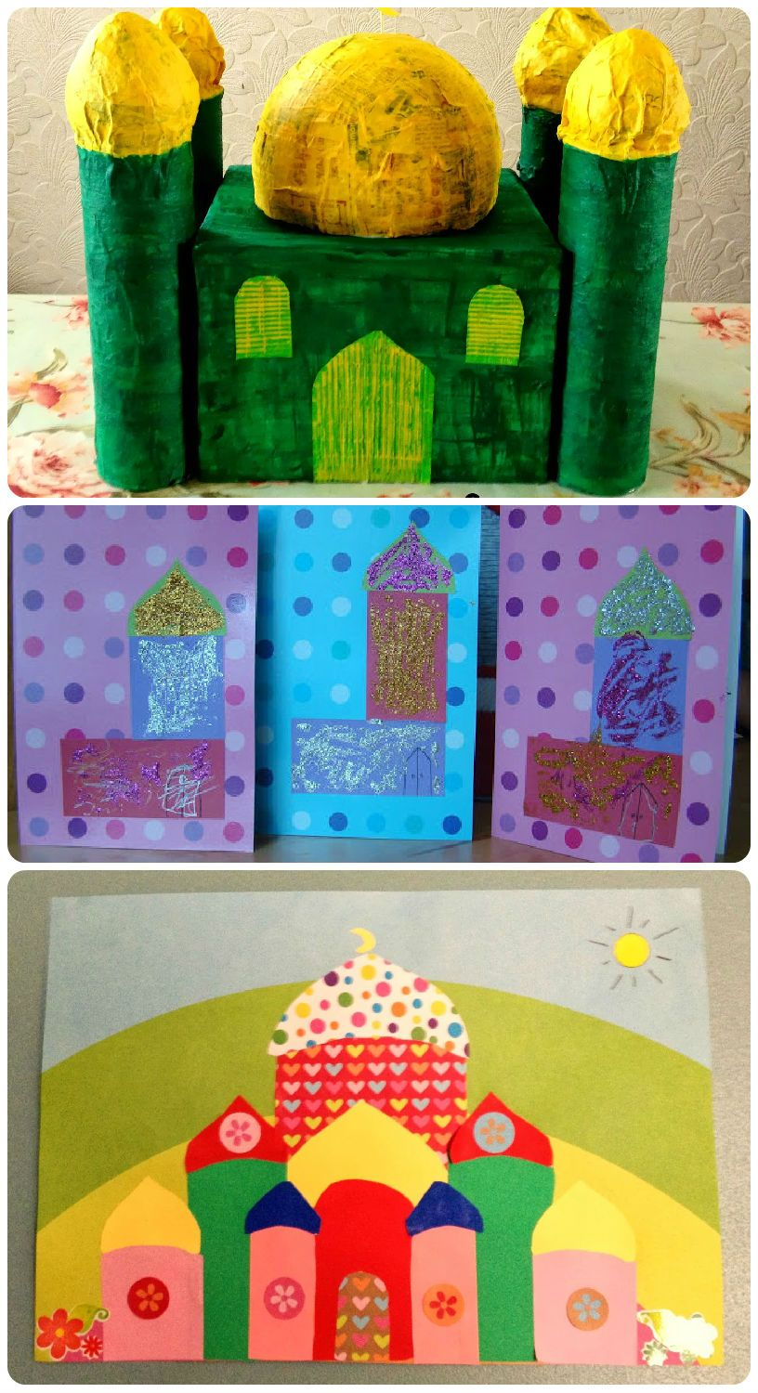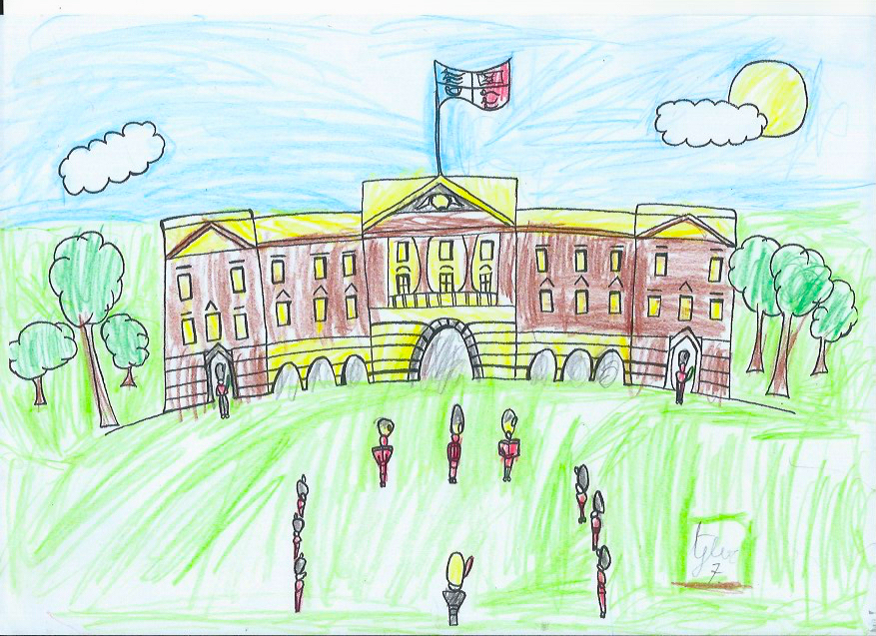

Please bring your home learning project into school by Thursday 10th January. We will open our doors at 3.20pm on this day to welcome parents to come inside and talk to the children about their projects.

