Friday 7th December Literacy Home Learning
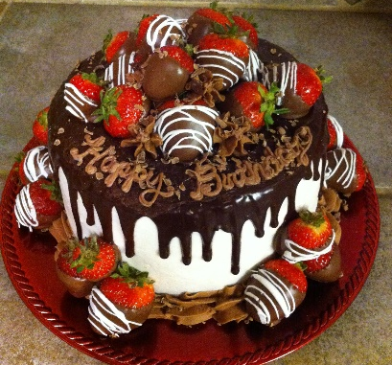

Task: To draw and design a birthday cake in the box below.
Support: Look at the different design of cakes and talk to your child about what they want their birthday to look like. Talk about the flavours, decorations and colour.
Challenge: Help your child label their cake using their phonics knowledge.
Draw your cake here:
Parent comment:

