23. 11. 18 Reception Maths Home Learning
This week in maths we are learning about 3D shapes, we have learnt about cube, cylinder, pyramid, cuboid, sphere, cone and triangular prism. We have explored these shapes and talked about their properties.
Task: Go on a 3D shape hunt and look for 3D shapes in the environment.
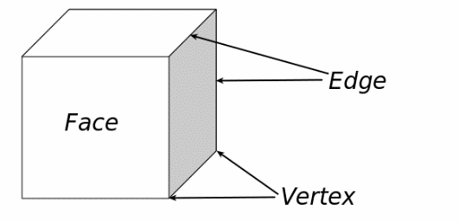
Support: Talk to your child about 3D shapes and how they are all around us. Talk about the faces, vertices and edges a 3D shape has. You may find some 3D shapes when you go shopping or in the park.
Example:

Challenge: Draw and label the 3D shapes you have found.
Draw and label 3D shapes

Parent’s comment

