23. 11. 18 Reception Literacy Home Learning
This week we explored and investigated pumpkins.
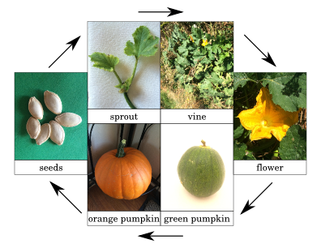
Task: Draw the life cycle of a pumpkin.
Support: With your child talk about the life cycle of a pumpkin. What is the first step in the life cycle of a pumpkin? How does a seed grow into a sprout? Think about things that make a pumpkin grow. Support your child in talking about the order of the pumpkin life cycle.
Challenge: Label the life cycle using your phonics knowledge, and remember to use your Fred fingers.
Life cycle drawing
Parent comments

