Year 3 Homework |  | Due: Wednesday 5th December 2018
Reading: Please continue to read every day for at least 15 minutes, recording your progress and completing the comments section within your reading diary. Reading diaries must be signed by your parent/carer before the book can be changed.
Record the answers to the following questions in your reading diary. What did you lie about the book? Why? What didn’t you like? How could it be improved?
Spelling: Practise the following at least 3 times for 10 minutes:
everybody | steak | behind | pretty | improve
Use one or more of the strategies listed on the ‘Strategies List’ located on the inside back cover.
English/Topic: Complete the Roman word search. |  |  | 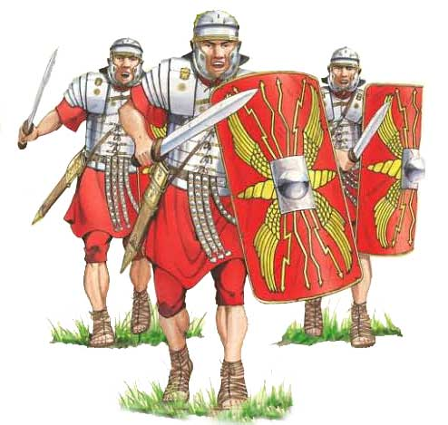
Support: Read each word and discuss their meanings with an adult.
Challenge: Write a definition for each word.
Maths: Using items found at home (i.e. playing cards, dice, counters, pasta), invent a game to play which will help you learn your times tables.
Support: Play your game with an adult.
Challenge: Write the instructions for your game.
Number Facts: Practise the multiplication and division facts for the 4 times table. How many questions can you answer in 1 minute? Log in to https://ttrockstars.com/ with your new login to engage with the times-table challenges.
Outdoor Learning: Head outside and explore how sunlight creates shadows with various objects such as trees, houses and cars. How does the sun's position in the sky affect the size of the shadows?
Next Week’s Learning:
English: We will be writing a non-chronological report explaining the impact Rome had upon Britain. | Maths: We will continue learning about multiplication and division using different methods. |  |  | Topic: We will be exploring how and when the Roman Empire eventually collapsed.
Parent/Carer Comment:

Child comment:

