Year 2 homework due in: Wednesday 14th November
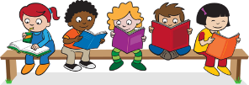
Reading: Please continue to read with your child every day. Record this in the reading record 3 times every week. Make a list of any interesting verbs you read.
Spelling: Please refer to the separate guidance for how to practise spellings.
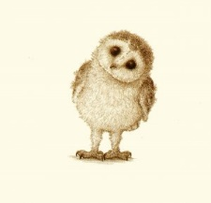
English:
Happy | Sad
Angry | Scared
Worried | Excited
Calm | Curious

This week we continued our work on the story of The Magic Porridge Pot. Draw your favourite scene in the story, and write some sentences about how the characters in that scene are feeling.

Support: Try using the feelings word bank
Challenge: Try and use some exciting new feelings vocabulary! You can use a dictionary, a thesaurus or the internet to help you.
Maths: We have started learning about multiplication. Find objects of home that you can group e.g. pasta, coins, sweets, etc. Make equal groups of the objects and write a multiplication number sentence about what you have made. For example, you could have 4 groups of 3 sweets each and 12 sweets in total.
4 x 3 = 12.
Support: Make groups using the 2s or 5s counting patterns. For example, 5 groups of 2 sweets each equals 10 sweets in total. 5 x 2 = 10.
Challenge: How many other ways can you write it? For example:
- 3 multiplied by 4 equals 12
- 3 fours = 12,
- 4 + 4 + 4 =12
Next Week’s Learning:
English:  We will be writing and editing our own  versions of  The Magic Porridge Pot. | Maths:  We will be continuing our learning about multiplication. | Topic:  We will be learning how to be safe when using household liquids and making some bubble art!
Outdoor learning: Gather some leaves that have fallen from trees. What do you notice about the sizes, shapes and colours? How are they different? How are they they same?
Parent/Carer Comment:

Child comment:

