Year 1 Homework Due in: Wednesday 7th November 2018
Reading: Please read with your child every day. Record this in the reading records 2-3 times every week. Please revise all phonics sounds you have learnt.
Spelling: Learn to spell the common exception words for year 1. You will find these in the front of your child’s reading records. Practise ten new words each week. You may choose to practise these orally, by writing them down or through spelling games.
English: We have been learning about letter writing this week. Please write a letter to your friend, describing what you know about space.
Support: Say your sentence and ask your adult to help you write it.

Challenge: Include conjunctions such as and, because, and so.

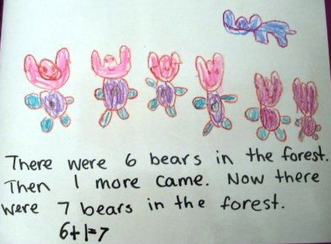
Maths: We have been revising how to add and make number stories. Write a number story for your friend to solve.

Support: Draw pictures to help your friend.

Challenge: Include another problem with a missing number challenge.
Outdoors: Go outside at night time and look at the moon. Does it change shape? Does it look different each night? Talk about what you notice and draw a picture if you wish.
Next Week’s Learning:
English:  Describing space story settings. | Maths:  Subtraction within 10 | Topic:  In science, we will be investigating the properties of materials.  In DT, we will be making an ‘ideas toolkit’ for our rockets.
Parent Comment:
Pupil Comment:

