02/11/18 Reception Maths Home Learning
This week we have been naming and describing 2D (flat) shapes and using them to make pictures.
Support: Help your child by looking for some of the shapes at home or when you are out and encourage them to name the shape they see and say how many corners and sides it has. Support your child to draw the objects you see for each shape in the correct box.

triangle | rectangle | circle
square | oval | 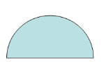  semi circle
hexagon | diamond | pentagon
Challenge: Below are some more uncommon 2D shapes, describe the shapes and draw objects you see that look like the shapes below.
Parent Comments:

