Year 1 Homework Due in: Wednesday 21th November 2018
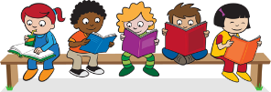
Reading: Please read with your child every day. Record this in the reading record 2-3 times every week. Please look at the list and revise all phonics sounds you have learnt.
Spelling: Learn to spell the common exception words for year 1. You will find these in the front of your child’s reading records. Practise ten new words each week. You may choose to practise these orally, by writing them down or through spelling games.
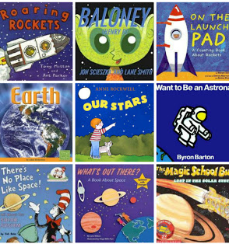
English: In preparation for our lesson on MONDAY 19th November, we would like your child to come into school ready to share their favourite space story. They may bring a labelled copy of the story if they want to. They may make their own story up and tell it orally.

Support: You might like to go to the library or use the internet to find children’s space stories. Practise talking about the story at home.

Challenge: Orally rehearse sharing your story and explain why you chose it.

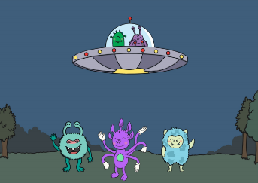
Maths: We have been learning about subtraction and writing subtraction stories. Draw a space picture that you can write a subtraction story for. Write your subtraction story. For example: “There are 5 aliens and 3 flew away. How many are left.”

Support: Ask an adult to help you record your subtraction story.

Challenge: Include another problem with a missing number challenge.
Outdoors: Next week we are learning about ordinal numbers, (1st, 2nd, 3rd etc.), linked to our maths work on positions. Go outside and have a race with your friends or family and talk about who came first, second and third etc. If you race again, does it change?
Next Week’s Learning:
English:  Gathering ideas and planning a space story. | Maths:  Developing language and apply new vocabulary to describe positions. | Topic:  We are beginning to plan and construct a model space vehicle.  Please begin to send in appropriate junk modelling materials such as cereal boxes and plastic bottles and lids. No toilet roll tubes please.
Parent Comment:
Pupil Comment:

