16. 11. 18 Reception Literacy Home Learning
This week we explored 1 less than a number up to 10.
Task: Count out a set of 20 toys into a cardboard box. The cardboard box is going to be a bus to take the toys on a journey. Move the box around the room and each time the bus stops, a toy gets off the bus. Count how many toys are left each time until the bus is empty.

Support: There are lots of songs you can sing to help you remember one less than each number. You could sing ‘10 Green Bottles’, ‘10 Little Men in a Flying Saucer’ or ‘5 Little Speckled Frogs’. You could try changing the songs to sing from 20! See ‘big numbers song’ on www.youtube.com.
Challenge: Count the numicon and write down what is 1 more and 1 less than each number.
1 more
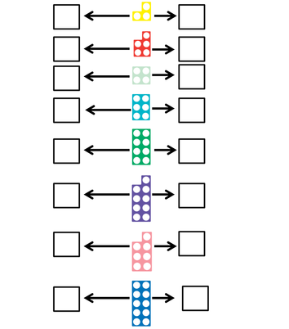
1 less

