16. 11. 18 Reception Literacy Home Learning
This week we read the story, ‘Pumpkin Soup’ and explored and investigated pumpkins.
Task: Use the recipe below to make pumpkin soup with your child. Try to take a picture and upload it to Tapestry so your child can share their experience with their class.
Support: With your child, talk about recipes and what you may need to make pumpkin soup. Talk about the texture, smell, look and taste of pumpkins before making the soup.
Pumpkin Soup
Ingredients:  - 1 small Pumpkin  - 1 onion  - 2 cloves of garlic  - 3 cups of water  - ½ cup of cream  - Pinch of salt  - Pinch of pepper | Recipe:  - Place peeled pumpkin, onion, garlic, broth and water into a pot.  - Boil rapidly for 15 minutes until pumpkin is very tender.  - Use a blender to blend to a smooth texture.  - Add salt and pepper to taste, then add cream.
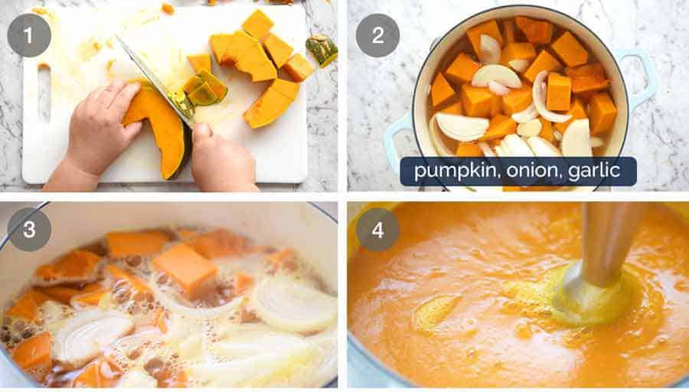

Challenge: Write a sentence about your favourite part of making the recipe.

