Year 2 homework due in: Wednesday 21st November
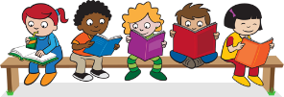
Reading: Please continue to read with your child every day. Record this in the reading record 3 times every week. Make a list of any interesting adjectives you read. Try writing them as rainbow words!
Spelling: Please refer to the separate guidance for how to practise spellings.
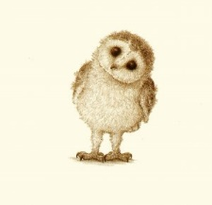
English:
This week we started writing our own stories based on The Magic Porridge Pot – The Magic Bubble Maker! Tell a grown up about the parts of the story we changed, and what we kept the same.

Support: Try drawing a story map to help you remember our story.

Challenge: Try to use some impressive adjectives to describe the things you changed.
Maths: We have continued our work on multiplication. On Tuesday, we learnt how to draw arrays to help us work out multiplication number sentences. Make up a number sentence, and draw an array to help you work it out. For example:

3 x 4 = 12
Support: Try doing this for counting patterns that you know. You could use your 2s, 5s or 10s counting patterns.
Challenge: How else could you write the number sentence? Can you write it as a real life example? For example, there are 3 groups of 4 apples, so there are 12 apples in total.
Next Week’s Learning:
English:  We will be making our Magic Bubble Maker stories into books and beginning our work on George’s Marvellous Medicine! | Maths:  We will be reviewing multiplication and beginning to learn about division! | Topic:  It is Art and Literacy week! We will be exploring how we can use Art to support our ideas in English.
Outdoor learning: Have a look at trees that have no leaves left. Look carefully at the colour of the bark and at the shapes of the branches. Have a go at drawing a tree.
Parent/Carer Comment:

Child comment:

