Year 3 Homework |  | Due: Wednesday 17th October 2018
Reading: Please continue to read every day for at least 15 minutes, recording your progress and completing the comments section within your reading diary. Reading diaries must be signed by your parent/carer before the book can be changed. Record the answers to the following questions in your reading diary. What happened within the story? Who is the main character? Where did the story take place? When was it set?
Spelling: Practise the following spellings at least 3 times for 10 minutes:
brake | break | grate | great | weight | wait
Use one or more of the strategies listed on the ‘Strategies List’ located on the inside back cover.
English/Topic: Write a diary entry about our trip to the Verulamium Museum. Remember to use time conjunctions (e.g. first, then, next, after that). |  |  |  | 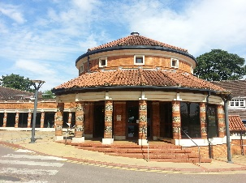
Support: Verbally tell your favourite part of the trip to your adult.
Challenge: Write a sentence describing the most interesting piece of knowledge you learnt on our trip.
Maths: Complete the subtraction calculations. What do you notice?

846 – 300 =
974 – 100 =
529 – 300 =

Support: Work with an adult. Will the ones (units) change? Will the tens change? Will the hundreds change? Can you explain why?
Challenge: Complete the following calculation using the column method: 764 - 512 =
Number Facts: Practise counting forwards and backward in multiples of 100 up to 1000 (and beyond - if you feel confident).
Outdoor Learning: In your local area, ask your grown up to help you find some evidence of Roman life out and about. Can you find Roman numerals? Can you find a Roman road? (Hint: They are very straight and long).
Next Week’s Learning:
English: We will be creating a character and writing our own myth. | Maths: We will be continuing our learning about subtraction, using the column method. |  | Topic: We will be exploring Roman mythology and creating our own mosaics. We will also be learning about modern Italian ways of life (i.e. Italian cuisine).
Parent/Carer Comment:

Child comment:

