5/07/18 Reception Maths Home Learning
Name:
Support: In maths this week we have introduced counting in 2s to 20. Help your child to count in 2s using a number line if needed.
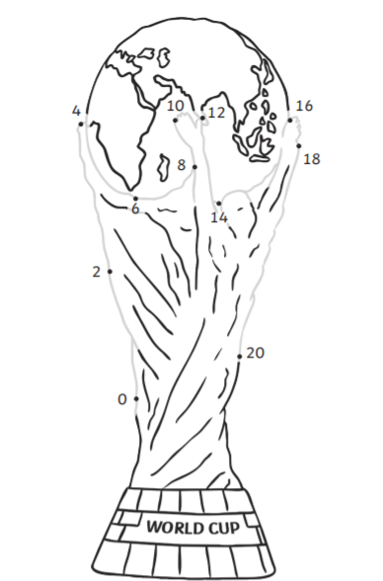
Challenge: We are enjoying talking about the World Cup in class! Complete the dot to dot counting in 2s. Colour in and cut out the trophy and bring to show in class.

Parent Comments:

