13/07/18 Reception Maths Home Learning
Name:
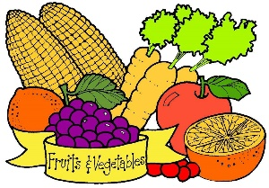
We have continued to read Handa’s Surprise and talk about the fruits that we enjoy eating. We discussed the importance of eating lots of fruits and vegetables to help us be our best on Sports Day!
Support: Talk to your child about how which fruits and vegetables they enjoy. Help your child to complete the tally chart below, adding a mark each time they eat a piece of fruit or vegetable for each day over the weekend. Which day did they eat the most? How many fruits and vegetables did they eat altogether?
Challenge: Encourage your child to complete a tally chart for somebody else in the family so they can compare scores.
Name | Day | Fruit and Vegetables Eaten | TOTAL
e.g. Harry Kane | Saturday | llll | 4
 | Sunday | lll | 3
 | Saturday
 | Sunday
 | Saturday
 | Sunday
Parent Comments:

