06/07/18 Reception Literacy Home Learning
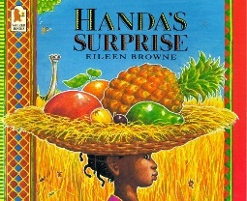
Name:
This week in Literacy we have been reading Handa’s Surprise. In the story there is a theme of fruit and we have been discussing which fruits we like and don’t like.
Support: Help your child to think of fruits they like and don’t like. Support them with saying the fruit names correctly. Encourage them to draw or cut out a picture of the fruits. Ask your child to write a label for each picture. Finally, find a new fruit for your child to taste and ask them to draw and label. Did they like it?
Challenge: Find out where in the world the fruits come from. Think of words to describe the fruits you have selected.
Fruits I like
Fruits I don’t like
A new fruit I tried
Parents Comments:

