Year 1 Homework Due in: Wednesday 11th July
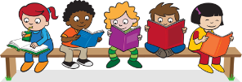
Reading: Please continue to read with your child every day. Record this in the reading records 2-3 times every week. Please revise all phonics sounds, especially those your child may be struggling with. For example; ir, au, aw, ear, are
Spelling: Please practise Year 1 spellings from the back of your homework book. You can choose a way to practise them from the ideas sheet.
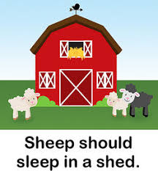
English: We will be learning about alliteration next week. Can you think of adjectives to go with your own name e.g crazy Kevin, amazing Anna, scary Sarah.

Support: Think of one word with the same sound as your name. Look at the examples above.

Challenge: Can you write a list of words to match your name. Remember to use alliteration!

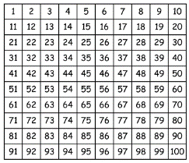
Maths: This week we have been learning about position. We have used words like above, under, in between, beside, in front of and behind.
Practice finding the number above, below, in between a particular number.
Support: Use a small toy and hide it in different positions. Describe where your toy is to your adult. Describe the position of number 38 on the number grid.

Challenge: Describe the position of 4 numbers on the 100 square.
Example:
27 is next to 28, before 29, under 17 and above 37
Outdoors: Go for a nature walk. Collect some items and make a simple collage. Bring your collage to school or take a photograph and email it.
Next Week’s Learning:
English:  ‘Where the Wild Things are’. We will be writing a non- chronological report about our own ‘wild thing’. | Maths:  Re-capping number including counting, ordering, tens and ones and grouping. | Topic:  Planning ideas to attract animals to our playground. We are hoping to build a bug hotel.
Parent Comment:
Pupil Comment:

