Year 2 homework due in: Wednesday 27th June
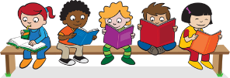
Reading: Please continue to read with your child every day. Please record this in the reading record 2-3 times every week. Look for verbs in the past tense. Can you think of any synonyms?

Spelling: Please practise Year 2 spellings from the back of your homework book. You can choose a new way to practise them from the ideas sheet.

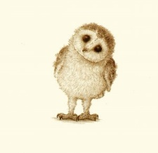
English: This week, the farm came to Watling Park. Draw your favourite farm animal and write some interesting facts. Use what you learnt during the visit as well as books and the internet. Share what you know with your family.

Support: Label the animals features and explain how they help.

Challenge: Write a paragraph about your chosen animal. Make it interesting by including as much detail as possible. Remember to include specific vocabulary related to the animal, i.e. feathers, fur, hooves, pen, crown, barn.
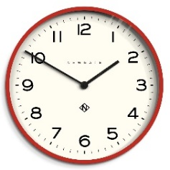
Maths: Play the ‘time game’ with a friend or someone in your family. You will need a die and 2 small objects to move around the board. The first person to move around the board wins.
Support: Use your ‘5 counting patterns’ to calculate the minutes.
Use ‘to the hour’ and ‘past the hour’.
Challenge: Say what time it will be half an hour/30 minutes after the time shown on the game sheet.
Next Week’s Learning:
English:  We will be exploring the life and art of Vincent Van Gogh. | Maths:  We will continue telling the time as well as exploring different durations. | Topic:  It is Art Week!  We will be investigating and recreating famous paintings by Vincent Van Gogh and David Hockney.
Outdoor learning: Sketch a plant or tree using the shading skills you have been taught.

Parent/Carer Comment:

Child comment:

