Year 1 Homework Due in: Wednesday 13th June
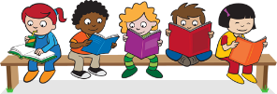
Reading: Please continue to read with your child every day. Record this in the reading records 2-3 times every week. Please revise all phonics sounds, especially those your child may be struggling with. For example; a_e, i_e, o_e, u_e as in cake, smile, phone, huge.

Spelling: Please practise Year 1 spellings from the back of your homework book. You can choose a way to practise them from the ideas sheet.
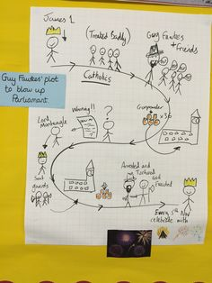
English: Recap the story of ‘We’re Going on a Bear Hunt’ with your child. Choose an alternative setting (e.g. a jungle) and draw a story map of possible obstacles (e.g. a swamp, a dark murky swamp).

Support: Draw the setting and label it with adjectives (describing words, e.g. wet, dark, noisy )

Challenge: Sequence the obstacles on your story map, adding key vocabulary (words you will find in your story).

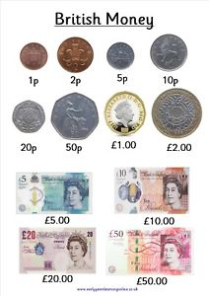
Maths: Next week we will be learning about money. Go to the shops and using real coins, show your children how to pay for something. Talk about the coins you use. Perhaps they could pay for something with the coins.
Support: Talk about the different colours and sizes of coins. What is the same? What is different?

Challenge: What coins could you use to pay for a teddy which costs 12p?
You could draw the coins to help you.

Outdoors: Go for a walk along your local high road. Talk about what you see on your journey. Did you find a post office, a bank, train station, bus stop, food shop, clothes shop?
Next Week’s Learning:
English:  Changing a story to show ‘bear hunts’ in different places We will be making small story books. | Maths:  Recognising British currency (coins and notes). | Topic:  We will be going for a walk to the local park (please hand in permission slips). Drawing and labelling our observations.
Parent Comment:
Pupil Comment:

