Year 2 homework due in: Wednesday 20th June
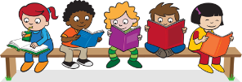
Reading: Please continue to read with your child every day. Please record this in the reading record 2-3 times every week. Look for verbs in the past tense. Can you think of any synonyms?

Spelling: Please practise Year 2 spellings from the back of your homework book. You can choose a new way to practise them from the ideas sheet.

English: In ‘The Lighthouse Keeper’s lunch’, Mrs Grinling makes a delicious packed lunch with cake, fruit, salads and sandwiches. Make a packed lunch with your parents and describe the different items using adjectives. E.g. a cheese sandwich made with soft, fresh bread.

Support: You can do this activity in your home language as well as English.

Challenge: Look up synonyms using an online thesaurus. E.g. instead of delicious you could use delightful or tasty.

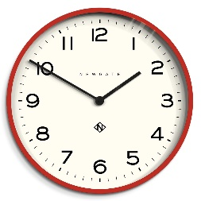
Maths: Talk about different activities and how long they take (e.g. half an hour, 5 minutes, an hour or an afternoon). How long does it take you to get to school? How long does it take to get dressed in the morning?
Support: Time short activities with a phone or watch. Work on smaller amounts of time such as 1 minute, 5 minutes and 1 hour.

Challenge: Thinking backwards! Give your child a duration of time and they have to suggest activities which might take that long. E.g. What do you that takes 30 minutes?
Next Week’s Learning:
English:  We will continue to use ‘The Lighthouse Keeper’s Lunch’ to inspire great diary writing and descriptions. | Maths:  We will continue to improve our telling the time skills. We will explore different durations of time. | Topic:  We will look at things that are dead, alive or have never been alive.
Outdoor learning: Go on a hunt and find things that are alive, dead or have never been alive.

Parent/Carer Comment:

Child comment:

