18/5/18 Reception Maths Home Learning

Support: We have been learning how to share quantities between groups. Help your child to read the letter below. Help them to cut out and share the cookies amongst Super Ted’s friends. Write down in each box how many cookies each superhero will get. What will you do with the extra cookies? Is there a way you can share them as well? Encourage them to use words such as ‘sharing’ and ‘equal’.

Challenge: Can you now share 10 cookies between the four superheroes. Can you tell your adult the amount you have shared out between the groups and if you managed to share them equally or not. Can you write it down as a number sentence for example “12 cookies can be shared equally between 3 groups? This can also be written like this: 3+3+3+3=12.
Then share 9 cookies between the four superheroes.
Dear Children,
I hope you can help me. I have heard you are great at problem solving and counting.
My mummy has given me a box of cookies! They look really yummy but Mummy says I can’t eat them all, I need to share them with my friends. I would like to make everyone happy but I don’t know how to share the cookies. How many cookies should I give my friends? How many should I get? Is it fair?
Love from
Super Ted
Parent Comments:

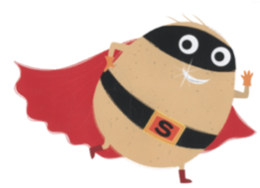

Cut out the cookies

