18/05/18 Reception Literacy Home Learning
Support: Reception have the opportunity to look after chicks in the classroom. Talk to your child about what they can see in the picture below. Help your child label the picture. Use the word bank below to support your child’s vocabulary.

Challenge: Talk to your child about how we can care for the chicks. On the back of the paper help to form sentences about what we can do to look after the chicks in class. Encourage them to use capital letters and full stops in their sentences.

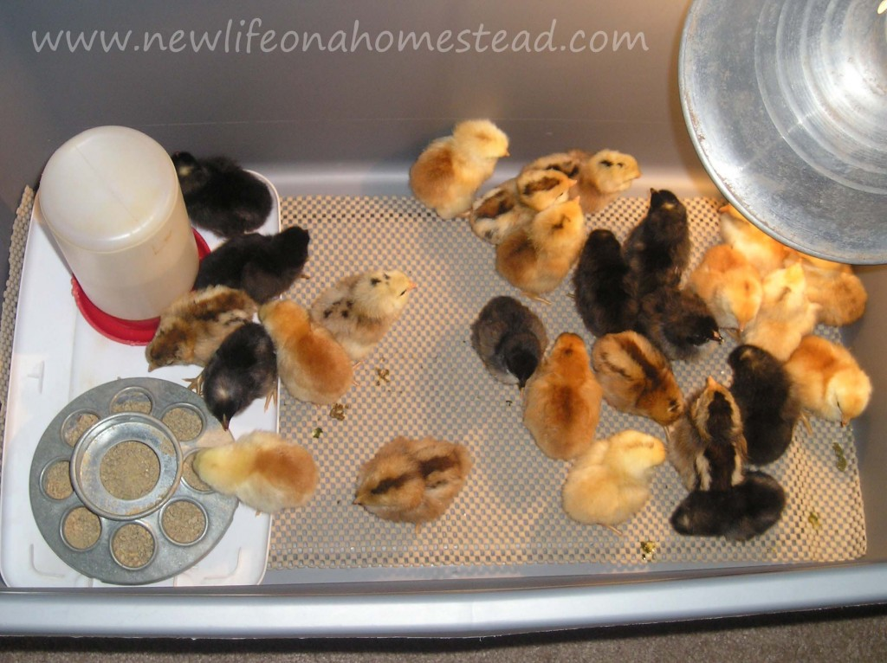

Word Bank
Incubator food water chicks light

Challenge: Write sentences about how we can look after the chicks?

Parents Comments:

