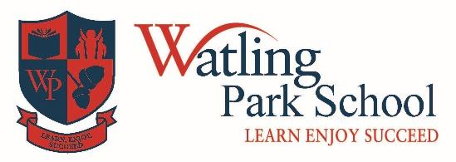British Value Statement at Watling Park School

**Overview**

Watling Park School is committed to serving our community and surrounding areas. We recognise the multi-faith nature of Barnet and the United Kingdom, and understand the crucial role our school plays in promote these values.

We encourage admissions of all entitled to education under British law, regardless of faith, ethnicity, gender, sexuality, political or ﬁnancial status. We educate all.

We aim to promote a love of learning in all our pupils which will stay with them into adulthood. We are in pursuit of excellence in all subjects.

This statement outlines the key British values.

**Tolerance of those with diﬀerent faiths and beliefs**.

Our RE curriculum provides a broad and balanced education about a range of faiths, religions and cultures. Children reﬂect on their own beliefs and those of others in a respectful way.

We have a growing number of pupils with additional languages, which we celebrate. We actively use school resources to promote their learning and full integration into school life. Through assemblies and topics taught in class, the children develop an understanding of a range of cultures to help them prepare for life in modern Britain.

**Individual Liberty**

Pupils have key roles and responsibilities in school.

At school, we educate and provide a supportive environment and boundaries within which children are actively encouraged to make safe and responsible choices.

Through a range of curriculum topics and clubs, pupils can make choices safely and demonstrate independence of thought and action.

**The rule of law**

We have a clearly structured ‘Behaviour Policy’, which all stakeholders understand and follow. Pupils demonstrate they understand and abide by our rules every day.

Some assemblies are delivered with a focus on the law.

We teach Philosophy for Children which encourages pupils to debate philosophical issues which are in the news or in law, or which aﬀect them personally.

**Mutual Respect**

Respect is a fundamental school value, around which pivots much of the work of the school. Our PHSE curriculum embodies values of mutual respect through units of learning such as relationships and being a responsible citizens. Our sports coaches and teachers actively promote an attitude of equality and fairness. We celebrate and reward success and learn to be magnanimous in defeat.

**Democracy**

Children are involved in the democratic process e.g. voting for school councillors, Eco-team members and shared rewards. The School Council itself is led by a member of staﬀ and adheres to democratic processes, reporting its actions to the whole school. Working in diﬀerent groups in their class and year groups enables pupils to learn to work cooperatively with turn taking and respect for the views of others. Our parents are able to share their views through a Parent Forum and questionnaires throughout the year.

Should you feel the school is not fulﬁlling this requirement, please contact the school oﬃce and request to express your concerns to a senior member of staff.