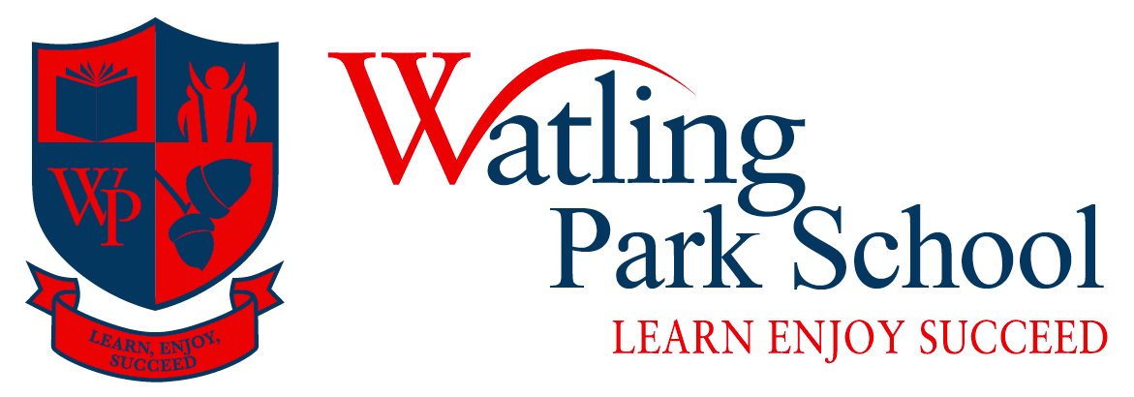

Data Protection Policy

This policy applies to all staff and pupils in the school, including in the EYFS

Signed: | 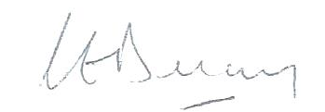
Chair of Trust Board: | Claire Delaney
Approved: | 3 November 2015
Renewal period | 2 Years
Review Date: | November 2017

Contents
What is Personal Data? 3
Good Practice in Information Handling 3
Making Sensitive Data Available To Those Who Need It 3
The Right of Employees to Access Personal Information 4
Videos and Photos 4
Use of Equipment Outside Of the School 4
Acceptable Use of ICT - Promoting the Effective Use of ICT 5

Data Protection Policy
The Watling Park School Data Protection Policy aims to ensure the appropriate confidentiality of sensitive information relating to staff, pupils, parents and governors. The policy aims enable members of the school community to process data within the guidelines of the Data Protection Act 1998. It is used to:
- Support its pupils’ teaching and learning
- Monitor and report on their progress
- Provide appropriate pastoral care
- Assess how well the school as a whole is doing

What is Personal Data?
The Information Commissioner's Office (ICO) defines personal data as:

- Information processed, or intended to be processed, wholly or partly by automatic means (information in electronic form such as on a computer)
- Information processed in a non-automated manner, which forms part of, or is intended to form part of, a 'filing system' (usually paper records)
- Information that forms part of an 'accessible record' (educational records) regardless of whether it is processed automatically or is held in a filing system
- Information held by a public authority

Good Practice in Information Handling
- All data should be kept safe and made available only to those who are authorised to access it
- Sensitive or personal data should not be removed from the school premises unless authorised by the Head. When data is required by an authorised user from outside the school premises – for example, by a teacher working from home – he/she should only do so via approved remote access to the management information system or learning platform and access the system using only private devices, e.g. a school device or device owned by the member of staff, they should not use publicly accessible devices e.g. in libraries or internet cafes
- Sensitive or personal data is deleted or destroyed when it is no longer required

Making Sensitive Data Available To Those Who Need It
From time to time, the school is required to pass data on to other organisations, including ISI and other inspection bodies, the DfE and the local authority. It may be necessary to pass sensitive information between staff in order to offer the best levels of teaching and care. The Data Protection Act states that this data can be 'processed' if necessary in order to carry out an obligation imposed by law in connection with employment. Safeguarding requirements, including the requirement to show evidence of safe recruitment practices, oblige the school to retain information for as long as is necessary, which data protection legislation would otherwise require to be destroyed.
We are sensitive in respect of information about our pupils. However, some information needs to be available in various areas of the school. For example, we have a list of pupils with particular medical conditions, which is available to staff, as required, and published on the staff room notice board, and information on pupils’ particular dietary requirements is displayed in the kitchen and dining areas of the school. Such information could be accessed by members of the public or other pupils.
Parents are able to request that the school makes available the data held on their children.

The Right of Employees to Access Personal Information

Staff who process personal information must comply with the following eight principles. They must ensure that the information is:
- Fairly and lawfully processed
- Processed for specified and limited purposes
- Adequate, relevant and not excessive
- Accurate and up-to-date
- Not kept for longer than is necessary
- Processed in line with the individual’s rights
- Kept secure
- Not transferred to other countries without adequate protection

Videos and Photos

The use of digital and video images plays an important part in learning activities and in communicating with parents about pupils’ learning, progress and welfare. Pupils and staff may use cameras and other equipment capable of taking photographs and video to record activities in lessons and out of school, provided they abide by the school’s policy on the use of cameras and mobile phones. Images may then be used in presentation, subsequent lessons and pupil records. In relation to the use of images in school publications, on the website and in public media, the school obtains parental consent and complies with the Data Protection Act. Further information is available in the cameras and mobile phones policy and a copy of the parental consent form is available from the school office.

Use of Equipment Outside Of the School

From time to time staff may be required, or may prefer, to perform school-related work at home, using either their own personal computers or devices or school-supplied equipment.
For school-owned equipment:
- equipment is to be kept in a safe place and not to be left in vehicles or in public places, which will constitute a breach of this policy
- Only password-protected equipment is allowed to leave the premises. Where the device is not password-protected, the member of staff is to contact the IT coordinator to set up appropriate password restrictions
- No software may be installed on the equipment without prior permission
- No files may be downloaded to the equipment unless these are being used directly in connection with school matters. Where files are downloaded to the equipment, the staff member is required to ensure that such files are downloaded from trusted sources, free of viruses, malware etc.
- No use of the school-owned equipment is permitted other than for school matters and always in accordance with this policy.
For privately-owned equipment;
- A member of staff may access his/her school email account from privately-owned equipment
- It is not permitted to download sensitive school data to private computers or devices. If in doubt as to what may be downloaded and worked on outside on private equipment, please seek advice beforehand from the head
            - By way of example, lesson materials may be downloaded, but class lists or individual reports, or documents containing sensitive personal data, may not be downloaded. The school uses cloud based MIS and reporting to ensure this is not necessary.

Acceptable Use of ICT - Promoting the Effective Use of ICT

Internet and digital communications technologies are powerful tools which open up new learning opportunities and can stimulate discussion and promote creativity. The school’s e-safety policy, available within the safeguarding policy aims to enable pupils to remain safe online both in and out of school.
Use of ICT:
Staff and pupils must respect others’ work and copyright. They should be polite and responsible when communicating with others, avoiding aggressive or inappropriate language. They should respect the security and integrity of the school’s ICT systems irrespective of whether the device belongs to the school. The use of personal devices, including mobile phones, tablets and USB devices in school must be in accordance with this policy and the school’s policy on the use of cameras and mobile phones. Staff and pupils should not open any attachments to emails, unless they are from known, trusted sources.

END

